EFFECT OF CROSS-LINKING WITH GINGER AND GARLIC ON THE PROPERTIES OF CASSAVA STARCH
J. Sudhakara Rao and R. Parimalavalli
Department of Food Science and Nutrition, Periyar University,
Salem- 636 011, Tamil Nadu, India.
Corresponding author: J. Sudhakara Rao, e-mail: brosudhakarpcu@gmail.com
Abstract
Cross-linking is a type of chemical modification to improve granule stability with new covalent bonds, thus providing desired functional properties. The present study was undertaken to modify cassava starch with active components of ginger and garlic and to determine the properties of modified cassava starch. The cassava starch was modified with 5 % ginger (A), 10 % ginger (B) and 5 % garlic (C), 10 % garlic (D). The degree of cross-linking was determined from the viscosity values, chemical and functional properties of all cross-linked starches were analyzed by standard methods. Results of the study showed that higher concentration of ginger and garlic increased the degree of cross-linking. Native cassava starch (0.60±0.09 %) had higher protein content than cross-linked cassava starches (0.11±0.02-0.57±0.01 %), amylose content was higher in cross-linked starch (22.72±0.52-27.15±0.19 %) than native starch (23.23±1.20 %). Water and oil absorption capacities were not significantly varied between native (0.96±0.01 g g⁻¹) and cross-linked starches (0.87±0.03 -0.93±0.04 g g⁻¹). Cross-linked starch had higher swelling power (14.50±0.45-14.79±0.36 g g⁻¹) and solubility (8.06±0.42-8.99±1.36 %) when compared to those of native starch (11.08±20.84 g g⁻¹ and 7.08±0.62 % respectively). Lower viscous properties were observed for cross-linked (1975.00 - 2565.00cP) starch than that of native starch (3733.66cP). Cassava starch could be modified with ginger and garlic; however distinctive properties were exhibited for cross-linked cassava starch compared to those of native cassava starch.
Key words: Cassava starch, cross-linking, garlic, ginger, pasting properties.
Introduction
Native starches, irrespective of their source are undesirable for many applications (Singh et al., 2007) because of their inability to withstand processing conditions such as extreme temperature, diverse pH, high shear rate and freeze-thaw variation. In order to improve the desirable functional properties, native starches are often modified. Modified starches have wide applications as binders, fillers, emulsion stabilizers, consistency modifiers and adhesives (Daramola and Osanyinlusi, 2006). Starch modification can be broadly grouped into four classes namely physical, chemical, enzymatic and biological modifications. Among these modification methods, chemical means is the most frequently used process (Daramola and Osanyinlusi, 2006). Chemical modification of starch involves the treatment of native starch with specific chemical reagents. This definition includes acetylated, oxidized, lintnerized, pyrodextrinized, hydroxypropylated and cross-linked starches (Kaur et. al., 2004). Chemical modification of cassava and other plant starches with improved qualities and applications have been reported by several workers (Ahmed et al., 2005; Jothi et al., 2005).
The active components of ginger root such as gingerol, dehydroginger-dione and shogaol (Kikuzaki and Nakatani, 1993) can be used as natural modifying agents for cassava starch and the modified starches characterized with stable viscosity, high swelling power which influences texture, a determining factor in consumer acceptance of some foods and improved solubility that depicts enhanced digestibility (Daramola and Osanyinlusi, 2006). Cross-linking treatment is intended to add chemical bonds at random locations in a granule and it stabilises the granule and strengthens the relatively tender starch (Acquarone and Rao, 2003). The most common type of chemical modification technique is cross-linking, the derivatization of starch by using a bi- or poly-functional chemical reagent that is able to react with two or more different hydroxyl groups on the same or different starch polymers (Wurzburg, 1986; Thomas and Atwell, 1999). It is well known that cross linked starches are less sensitive to processing conditions (high temperature, extended cooking times, low pH, high shear during mixing, milling, homogenization and pumping) than native starches (Whistler and BeMiller, 1997). Cross-linking reinforces the already present hydrogen bonds in the granules with new covalent bonds. As a result, cross-linked starch is more resistant to acid, heat and shearing than native starch (Hoseney, 1994; Mirmoghtadaei, et al., 2009).
Starch modification involves the alteration of chemical, physical and functional properties of native starches. This alteration has the main objective of producing more satisfactory products for specific food applications. The starches most commonly modified for commercial use are those from normal maize, tapioca, potato and waxy maize. Modified starches are used to improve viscosity, shelf stability, particulate integrity, processing parameters, texture, appearance and emulsification. Different starches have different properties and are used in the food industry for nutritional, sensory and even aesthetic purposes (Rapaille, 1995). Cross-linking at low levels, have a substantial effect on properties such as granule swelling, paste viscosity, and retrogradation (Reddy and Seib, 1999). The objectives of this study was to modify the native cassava starch with natural cross linking reagents such as ginger and garlic and to determine the properties of cross linked cassava starches.
Materials and methods
Cassava native starch (CNS) was isolated from cassava roots according to the method of Vasanthan (2001). Ginger and garlic were purchased from local market in Salem, Tamil Nadu. Starches were modified with two cross linking agents such as ginger and garlic and two different concentrations (5% and 10%), according to the method described by Daramola and Osanyinlusi (2006) with slight modification. Ginger and garlic were cleaned and peeled. The peeled roots were crushed and mixed with starch-water suspension and stirred periodically for 30 minutes at room temperature. Ginger and garlic grates were sieved out and starch milk obtained was washed and the water removed using suction pump. The starch obtained was dried using air oven and ground with mortar and pestle to obtain modified starch, namely A (cassava native starch with 5% ginger), B (cassava native starch with 10% ginger), C (cassava native starch with 5% garlic) and D (cassava native starch with 10% garlic) respectively.
Determination of degree of cross linking (%)
The degree of cross linking of the cross linked starches was determined from the viscosity values, according to the method of Chatakanonda et al. (2000). The peak viscosities of the starch samples were recorded using a Rapid Visco Analyzer (RVA Tech master, Perten, Instruments Japan). The starch slurry (10% by weight) was heated from 50 - 95 ºC/min at 12 ºC/min at 160 rpm and then held at 95 ºC for 2 min. Afterwards the paste was cooled to 50 ºC at 12 ºC/min and finally kept at 50 ºC for 2 min. The degree of cross linking was calculated as follows
A-B
Degree of cross linking = × 100
B
Where, A is the peak viscosity in RV units of the native starch and B is that of the cross-linked starch.
Protein and amylose content (%)
The crude protein and amylose content was determined by the method of AOAC, (1990) and Williams et al (1970) respectively.
Functional properties
Water and oil absorption capacity (g g ⁻¹)
Measurement of water/oil absorption capacity was done by the method of Beuchat et al (1977).

Swelling power (g g ⁻¹) and solubility (%)
Swelling power and solubility pattern were studied by the method of Leach et al. (1959) at a temperature interval of 10ºC from 40-90 ºC. In this method, one gram of the starch was suspended in 50 ml of distilled water and kept in a water bath for 30 minutes. The suspension was then removed and centrifuged for 15 minutes at 2200 rpm. The supernatant was allowed to evaporate at 120 ºC and the residue thus obtained was subjected to the measurement of the percent solubility of starch in water. The swelling power was calculated as weight of the paste sediment per gram of dry starch.
Pasting properties
Pasting properties of native and modified cassava starch were measured with the Rapid Visco Analyzer (RVA Tech master, Perten, Instruments Japan) (Xiao et al., 2012). Viscosities of starches were recorded with starch suspensions (moisture content 12%, sample 3 g, water 25 ml) that underwent a controlled heating and cooling cycle under constant shear, where the sample was held at 50 °C for 1 min, heated from 50 °C to 95 °C at 5°C/min and held at 95 °C for 2.7 min, cooled from 95 °C to 50 °C at 5 °C/min and held at 50 °C for 2 min. The speed of blending was maintained at 160 rpm. Pasting parameters such as peak viscosity, trough viscosity, break down, final viscosity, set back, peak time and pasting temperature were recorded.
Statistical analysis
Data were analyzed using single factor ANOVA in Microsoft Excel (2003). The analyses were done in triplicates.
Results and Discussion
The degree of cross-linking of the cross-linked cassava starch was determined from the RVA viscosity values and the results are presented in Table 1. It was observed that the degree of cross-linking increased with increasing concentration of natural cross-linking reagents (ginger and garlic active components). Xiao, et al. (2012) reported that the degree of cross-linking increased with increasing concentration of epichlorohydrin (EPI). The degree of cross-linking ranged from 30.15-46.14%. This result is confirmed with Xiao et al. (2012) who stated that the degree of cross-linking of rice starch ranged from 18.71 – 72.41%. Higher level of cross-link of starch retarded the swelling of granule and resulted in a lower peak viscosity. The degree of cross-linking increased with increasing concentration of natural cross-linking reagents, this could be due to the bi-functional entities containing an activated double bond as well as hydroxyl/methoxy phenyl residues (Stauffer, 1990) and sulphur compounds present in active ginger and garlic components such as gingerol, dehydroginger-dione, shorgal and allicin (Daramola and Osanyinlusi, 2006).
The protein content of native and cross-linked starches is presented in Table. 1. The protein content of cross-linked starches was significantly lower than that of native cassava starch (0.60%). With increasing concentration of cross-linking agents, the protein content decreased. Native starch cross-linked with garlic 5% (0.57%) had high protein than all other modified starches. This result is in conformity with the report of Aparicio-Saguilán, et al. (2008) who stated that the protein content of cross-linked banana starch ranged from 0.53 to 0.55 % and the reagents used in the chemical modification of starch solubilized an important fraction of proteins, thus reducing their levels in the cross-linked preparation (Aparicio-Saguilán et al., 2005).
Amylose content of native and cross-linked cassava starches is presented in Table 1. The amylose content of native cassava starch was significantly lower than the cross-linked starches. With the increase in the concentration of cross-linking agents, the amylose content increased. Native starch cross-linked with ginger 10% (27.15%) had high amylose than native starch cross-linked with garlic 10% (25.97%), native starch cross-linked with ginger 5% (25.00%), and native starch cross-linked with garlic 5% (22.72%). The amylose content of native and cross-linked starches ranged from 22.72 - 27.15%. This result is similar to the reports of Dzogbefia et al., (2008) who stated that the amylose content of native cassava starch was 24.50 %. Cross-linking with ginger and garlic components might be occurred in the outer regions of the granules and located on the amylopectin molecules. Though cross-linking preferentially occurred in amylopectin, some amylose molecules were cross-linked to amylopectin (Jane et al., 1992). These amylose molecules will be protected from acid hydrolysis. Therefore, amylose hydrolysis decreased after cross-linking resulting in higher percentage of amylose and consequently lower relative crystallinity when compared to that of the acid-modified non cross-linked starch (Atichokudomchai and Varavinit, 2003). Wurzburg, (1986) reported that during acid modification, the amount of starch amylose increases, indicating that acid preferably hydrolyses amylopectin.
Table 1. Degree of cross-linking, protein and amylose content of native and cross-linked cassava starch
Sample | Degree of cross-linking (%) | Protein (%) | Amylose (%)
NCS | Nil | 0.60±0.09ª | 23.23±1.20ª
A | 39.36±9.86 | 0.44±0.07^{b} | 25.00±1.21^{b}
B | 46.14±12.66 | 0.11±0.02^{c} | 27.15±0.19^{c}
C | 30.15±13.45 | 0.57±0.01^{d} | 22.72±0.52ª
D | 37.46±6.19 | 0.21±0.08e | 25.97±0.19^{db}
CD (0.05) | - | 0.08 | 1.13
Mean values superscripted by the same letter are not significantly different within the columns. Mean values of three measurements± standard deviation, NCS= native cassava starch, A = cassava native starch with 5% ginger, B = cassava native starch with 10% ginger, C = cassava native starch with 5% garlic and D = cassava native starch with 10% garlic

The water and oil absorption capacity of the native and cross-linked starches are presented in Table 2. The modified starches with higher degree of cross-linking exhibited a decrease in the water (WAC) and oil absorption capacity (OAC). However, when compared to native starch (1.10 g g ⁻¹ WAC and 1.45 g g ⁻¹OAC), the cross-linked starches exhibited higher level in water (0.87-0.93 g g ⁻¹) and oil (1.09-1.27 g g ⁻¹) absorption capacity values. On the other hand, Yook et al. (1993) reported a decrease in the water uptake of rice starch upon cross linking with EPI. Kaur et al. (2004) observed a considerable lowering of WBC of cross-linked potato starches in comparison to the native counterparts. Choi and Kerr (2003) reported that cross-linking at low concentration of phosphorus oxychloride had little effect on the dynamic water properties of wheat starch.
Table 2. Water and oil absorption capacity of the native and cross linked starches
Sample | Water absorption capacity (g g ⁻¹) | Oil absorption capacity (g g ⁻¹)
NCS | 0.96±0.01 | 1.45±0.05
A | 0.92±0.06 | 1.16±0.03
B | 0.87±0.03 | 1.09±0.10
C | 0.93±0.04 | 1.27±0.20
D | 0.88±0.02 | 1.23±0.16
NCS= native cassava starch, A = cassava native starch with 5% ginger, B = cassava native starch with 10% ginger, C = cassava native starch with 5% garlic and D = cassava native starch with 10% garlic

Sample | Temperature (ºC)
Sample | 40 | 50 | 60 | 70 | 80 | 90
NCS | 2.21±0.19ª | 3.01±0.19ª | 3.61±0.14ª | 5.12±0.26ª | 11.08±20.84ª | 15.41±2.88ª
A | 3.08±0.74^{b} | 4.57±0.81^{b} | 5.62±0.61^{b} | 10.68±0.10^{b} | 14.50±0.45^{b} | 11.03±0.20^{b}
B | 3.52±0.02^{cb} | 5.39±0.67^{cb} | 6.23±0.61^{cb} | 11.38±0.50^{c} | 14.70±0.46^{cb} | 10.95±0.20^{cb}
C | 3.46±0.63^{db} | 4.64±0.64^{db} | 5.82±0.73^{db} | 11.03±0.07^{db} | 14.79±0.36^{db} | 11.08±0.50^{db}
D | 3.54±0.03^{eb} | 5.51±0.57e | 6.27±0.07^{eb} | 11.75±0.30e | 14.76±0.45^{eb} | 10.99±0.19^{eb}
CD (0.05) | 0.63 | 0.86 | 0.72 | 0.41 | 0.76 | 1.86
Table 3. Swelling power ((g g ⁻¹)) of native and modified cassava starches
Means superscripted by the same letter are not significantly different within the columns. NCS= native cassava starch, A = cassava native starch with 5% ginger, B = cassava native starch with 10% ginger, C = cassava native starch with 5% garlic and D = cassava native starch with 10% garlic

The swelling powers of native and cross-linked starches are given in Table 3. The results are consistent with the earlier reports (Liu et al. 1999; Hirsch and Kokini, 2002). According to Kartha and Srivastava (1985) with increase in the degree of cross-linking, the granular structure of starch becomes more compact and swelling and solubility are reduced. Swelling power of native starch gradually increased at higher temperature (40-90ºC), but swelling power of cross-linked starch increased up to 80ºC and then it decreased at 90ºC. These results are in conformity with that of Carmona-Garcia et al. (2009) who reported that the swelling power of cross-linked banana starch increased with increasing temperature, but at 90ºC, it decreased. This could be due to the bi-functional entities containing an activated double bond as well as hydroxyl/methoxy phenyl residues present in active ginger components such as gingerol, dehydroginger-dione and shogaol (Kikuzaki and Nakatani, 1993).
The solubility of native and cross-linked starches in water are given in Table 4. The solubility of the native starch was 1.09-8.46% and those of the modified starches in the four sets of experiments were 1.88–7.08, 2.8–6.41, 7.07-2.23 and 2.65–6.85%, respectively. The cross-linked starches showed lower solubility in comparison to the native starch. The solubility decreased with an increase in reagent concentration, which could be attributed to the increase in the degree of cross-linking and also consistent with the swelling power observed. Due to the strengthening of the starch granules through cross-links, less disintegration took place during gelatinization and lowering of solubles. Cross-linking reduces the solubles which leach out of the swollen granules on cooking and the extent of solubilization is affected by the degree of cross-linking; the fewer the cross-links the higher would be the solubles (Wurzburg, 1986). According to earlier reports also the cross-linked starches exhibited a lower solubility than the native starch (Liu et al. 1999; Hirsch and Kokini, 2002). According to Liu et al. (1999) who observed lowering of solubility of cross-linked waxy rice starches, cross-linking restricts swelling of granules and will also lower solubility by increasing chain binding.
Table 4. Solubility (%) of native and modified cassava starches
Sample | Temperature (ºC)
Sample | 40 | 50 | 60 | 70 | 80 | 90
NCS | 1.09±0.19a | 1.87±0.17a | 2.26±0.33a | 6.28±0.29a | 7.08±0.45a | 8.46±0.44a
A | 1.88±0.47b | 2.60±0.17b | 3.63±0.77b | 6.66±1.32a | 8.80±1.55b | 7.083±0.62b
B | 2.80±0.42c | 3.27±0.12c | 4.10±0.63cb | 7.73±1.23a | 8.99±1.36cb | 6.41±0.72cb
C | 2.23±0.73dbc | 3.03±0.10dc | 4.13±0.31db | 7.02±0.33a | 8.74±0.58ab | 7.07±0.27db
D | 2.65±0.58ec | 3.49±0.50ebc | 4.20±0.14eb | 7.87±0.58ba | 8.06±0.42ab | 6.85±0.83eb
CD (0.05) | 0.75 | 0.37 | 0.70 | - | - | 0.86
Means superscripted by the same letter are not significantly different within the columns. NCS= native cassava starch, A = cassava native starch with 5% ginger, B = cassava native starch with 10% ginger, C = cassava native starch with 5% garlic and D = cassava native starch with 10% garlic

Pasting (RVA) characteristics of native and modified cassava starches are shown in Fig. 1 and Table 5. The peak (1975.0-256.0) viscosity of cross-linked starches was lower when compared with the native starch peak (3733.7) viscosity and gradual it decreased with the increase the degree of cross-linking. Jyothi et al. (2006) and Xiao et al. (2012) indicated that the peak viscosity decreased at higher levels of cross-linking. Cross-linking strengthened the bonding between starch chains and increased the resistance of the granules to swelling, leading to low peak viscosity (Xiao et al. 2012). In the higher level of cross-links, there were sufficient cross-links to inhibit the swelling of the starch and there was a decrease in viscosity (Kaur, 2004). Native (1747.3) starch had the highest trough viscosity than cross-linked (1082.0-1601.0) starches. Trough viscosity decreased with increasing concentration of cross-linking agents. Cross-linked starches showed lower breakdown (770.0-963.3) than native (1986.3) starch, which could be attributed to the strengthening of the swollen granules against breakage under conditions of high temperature and shear (Jyothi et al. 2006). Final viscosity of cross-linked (1678.0-2325.7) starches was significantly lower than the native (2592.7) starch. Final viscosity was decreased with increasing concentration of cross-linking agents. The set back (579.0-746.3) value of cross-linked starches were lower when compared with the native starch (845.3) and it gradually decreased with the increasing degree of cross-linking. Jyothi et al. (2006) and Xiao et al. (2012) indicated that the setback values decreased at higher levels of cross-linking. The peak time (4.24-4.27 min) of cross-linked starches was higher than the native starch (4.24 min), but no significant differences were observed among the various starches. Pasting temperature of cross-linked starches increased in comparison to that of the native starch and it increased with increasing levels of cross-linking. This result is similar to the report of Jyothi et al. (2006) who stated that the pasting temperature of cross-linked
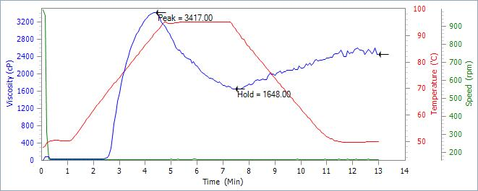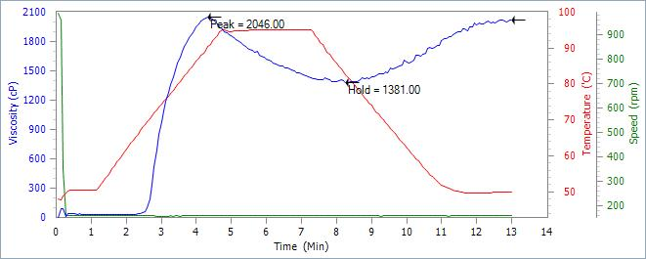
Native cassava starch Sample - A
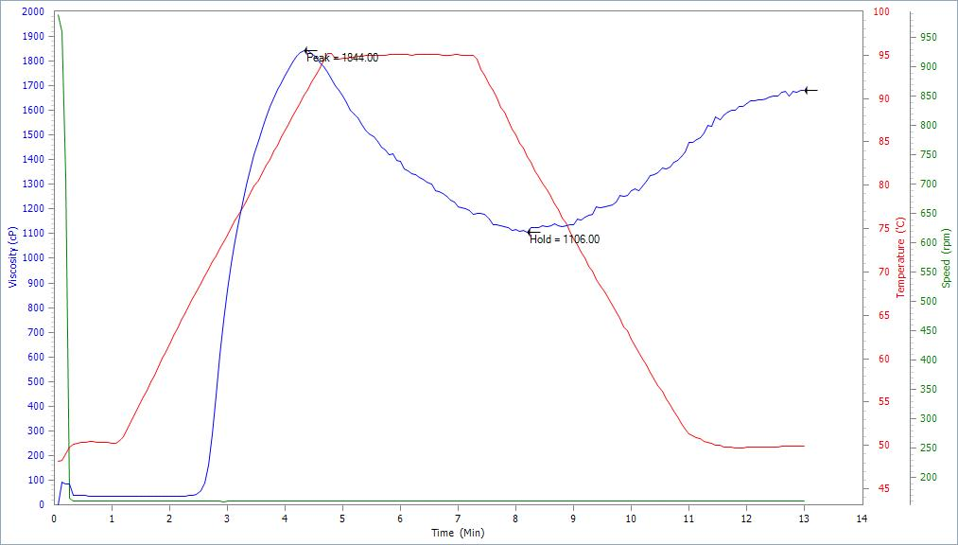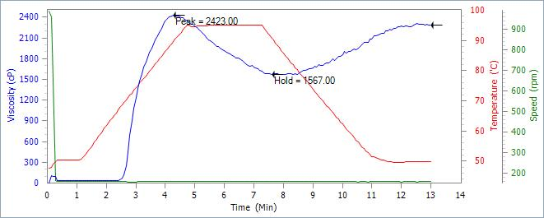
Sample - B Sample - C
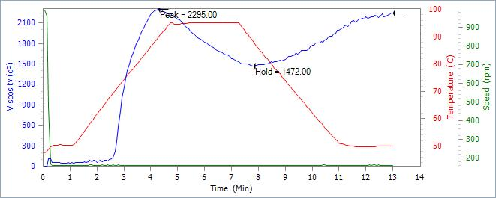
Sample – D
Figure 1. RVA patterns of native and cross-linked cassava starch.
cassava starches increased when compared to the native starch. Cross linking of molecular chains makes the starch granules more ordered and consequently more energy would be required for swelling (Kartha and Srivastava 1985). With increase in the level of cross-linking, the gelatinization temperature also increased (Xiaoi et al. 2012).
Table 5 Pasting (RVA) characteristics of native and cross –linked cassava starches.
Sample | Peak viscosity (cP) | Trough viscosity (cP) | Break down (cP) | Final viscosity (cP) | Set back (cP) |  | Peak time (min) | Pasting temperature (°C )
NCS | 3733.66±533.82ª | 1747.33±184.30ª | 1986.33±349.92ª | 2592.66±275.88ª | 845.33±91.57ª | 4.24±0.16 |  | 67.83±0.07
A | 2136.00±193.65ª | 1366.00±36.16^{b} | 770.00±173.85^{b} | 2075.50±76.95^{b} | 709.50±74.06^{b} | 4.26±0.31 |  | 67.82±0.02
B | 1975.00±287.80^{b} | 1082.00±33.94^{c} | 876.00±256.53^{cb} | 1678.00±73.54^{c} | 579.00±36.16^{c} | 4.26±0.11 |  | 68.15±0.47
C | 2565.00±239.05^{b} | 1601.66±135.37ª | 963.33±118.19^{db} | 2325.66±146.11^{d} | 724.00±11.00^{db} | 4.24±0.04 |  | 62.38±10.21
D | 2313.00±93.31^{ca} | 1425.00±153.82^{db} | 887.33±79.34^{eb} | 2172.00±165.21^{ebd} | 746.33±22.67^{eb} | 4.27±0.00 |  | 65.16±6.77
CD (0.05) | 432.54 | 176.79 | 307.91 | 232.47 | 79.25 | - |  | -
Means superscripted by the same letter are not significantly different within the columns. Mean values of three measurements± standard deviation, NCS= native cassava starch, A = cassava native starch with 5% ginger, B = cassava native starch with 10% ginger, C = cassava native starch with 5% garlic and D = cassava native starch with 10% garlic
Conclusion
The present study indicated that the active components of ginger and garlic at 5 and 10 % concentration modified the native starch with reduction in protein, water and oil absorption capacity. The peak viscosity of cross-linked starches was lower when compared with the native starch. The pasting temperature of native starch was higher than cross-linked starches. Cross-linked cassava starch could be used widely in many food applications with desirable functional properties.
Reference
A.O.A.C. 1990. Official methods of Analysis, Association of official Analytical Chemistry. 15th Edition.
Acquarone, V.M. and Rao, M. A. 2003. Influence of sucrose on the rheology and granule size of cross-linked waxy maize starch dispersions heated at two temperatures. Carbohydr Polym., 51: 451–458.
Ahmed, A.S., Igbo, U.E. and Igwe, C.C. 2005. Evaluation of the physico-chemical properties of acid thinned cassava starch. Nig. Fd. J., 23: 85-90.
Aparicio-Saguilán, A., Flores-Huicochea, E., Tovar, J., García- Suárez, F., Gutierrez-Meraz, F. and Bello-Pérez, L.A. 2005. Resistant starch-rich powder prepared by autoclaving of native and lintnerized banana starch: Partial characterization. Starch/ Stärke, 57: 405–412.
Aparicio-Saguilán, A., Gutiérrez-Meraz, F., García-Suárez, F.J., Tovar, J. and Bello-Péreza, L. A. 2008. Physicochemical and functional properties of cross-linked Banana resistant starch. Effect of pressure cooking. Starch/ Stärke, 60: 286–291.
Atichokudomchai, N. and Varavinit, S. 2003. Characterization and utilization of acid-
modified cross-linked Tapioca starch in pharmaceutical tablets. Carbohydrate
Polymers, 53: 263–270.
Beuchat, L. R. 1977. Functional and electrophoretic characteristics of succinylated peanut flour protein. J. Agric. Food Chem., 25: 258-261.
Carmona-Garcia, R., Sanchez-Rivera, M. M., Mendez-Montealvo, G., Garza-Montoya, B. and Bello-Perez, L.A. 2009. Effect of the cross-linked reagent type on some morphological, physico-chemical and functional characteristics of banana starch (Musaparadisiaca). Carbohydrate Polymers, 76: 117–122
Chatakanonda, P., Varavinit, S. and Chinachoti, P. 2000. Relationship of gelatinization and recrystallization of cross-linked rice to glass transition temperature. Cerea. Chem., 77: 315–319.
Choi, S.G.M. and Kerr, W.L. 2003. Effects of chemical modification of wheat starch on molecular mobility as studied by pulsed 1HNMR. Lebensm.-Wiss. Technol., 51: 1–8.
Daramola, B. and Osanyinlusi, S.A. 2006. Investigation on modification of cassava starch using active components of ginger roots (Zingiber officinale Roscoe). African J. of Biotec., 5 (10): 917-920.
Dzogbefia, V.P., Ofosu, G.A. and Oldham, J.H. 2008. Physico-chemical and pasting properties of cassava starch extracted with the aid of pectin enzymes produced from Saccharomyces cerevisiae ATCC52712. Scientific Research and Essay, 3 (9): 406-409.
Hirsch, J.B. and Kokini, J.L. 2002. Understanding the mechanism of cross-linking agents (POCl3, STMP and EPI) through swelling behavior and pasting properties of cross-linked waxy maize starches. Cereal Chem., 79: 102–107.
Hoseney, R. C. 1994. Starch, in Principles of Cereal Science and Technology, 2nd ed. American Association of Cereal Chemists International, St. Paul, Minnesota, pp. 54–57.
Jane, J., Xu, A., Radosavljevic, M. and Seib, P.A. 1992. Location of amylose in normal starch granule. I. Susceptibility of amylose and amylopectin to crosslinking reagents. Cereal Chemistry, 69: 405–409.
Jyothi, A.N., Moorthy, S.N. and Rajasekharan, K.N. 2006. Effect of cross linking with epichlorohydrin on the properties of cassava starch. Starch/Stärke, 58: 292-299.
Jyoth, A.N., Sasikirana, K., Sajeeva, M.S., Revammab, R. and Moorthya, S.N. 2005. Gelatinization properties of cassava starch in the presence of salts, acids and oxidizing agents. Starch/Starke, 57 (11): 547-555.
Kartha, K.P.R. and Srivastava, H.C. 1985. Reaction of epichlorohydrin with carbohydrate polymers. Starch/Stärke, 37: 297–306.
Kaur, L. 2004. Physico-chemical properties of potatoes in relation to thermal and functional properties of their starches. Ph.D. Thesis, Guru Nanak Dev University, Punjab, India, pp. 140–146.
Kaur, L., Singh, N. and Singh, J. 2004. Factors influencing the properties of hydroxypropylated potato starches. Carbohydrate Polymers, 55: 211-223.
Kikuzaki, H. and Nakatani, N. 1993. Antioxidative effect of some ginger constituents. J. Food Sci., 58: 1407– 1410.
Leach, H.W., Mc Cowen, L.D. and Scoch, T.J. 1959. Structure of the starch granule I. Swelling and solubility patterns of various starches. Cereal Chem., 36: 534-544.
Liu, H., Ramsden, L. and Corke, H. 1999. Physical properties of cross-linked and acetylated normal and waxy rice starch. Starch/Stärke, 51 (7): 249–252.
Mirmoghtadaei, L., Kadivar, M. and Shahedi, M. 2009. Effect of cross-linking and acetylation on oat starch properties. Food Chem., 116: 709-713.
Rapaille, A. 1995. Use of starch in heat processed food. London. Food Tech. International Europe, 73-76.
Reddy, I. and Seib, P.A. 1999. Paste properties of modified starches from partial waxy wheats. Cereal Chem., 76:341–349.
Singh, J., Kaur, L. and Mc Carthy, O.J. 2007. Factors influencing the physico-chemical, morphological, thermal and rheological properties of some chemically modified starches for food applications-A review. Food Hydrocol., 21: 1-22.
Thomas, D.J. and Atwell, W.A. 1999. Starches. Eagan Press, St. Paul, 31–48.
Vasanthan, T. 2001. Overview of Laboratory Isolation of starch from plant Materials. Food analytical chem. E2.1.1-E2.16.
Whistler, R.L. and BeMiller, J.N. 1997. Carbohydrate Chemistry for Food Scientists, Eagan Press, St. Paul, 117– 151.
Williams P.C., Kuzina F.D. and Hlynka I. 1970. A rapid colorimetric procedure for estimating the amylase content of starches and ﬂours. Cereal Chemistry, 47: 411–420.
Wurzburg, O.B. 1986. Cross-linked starches. In Modified Starches: Properties and Uses Wurzburg, O.B. (Ed). CRC Press. Florida, 42–51.
Wurzburg, O.B. 1986. Modified starches: properties and uses. CRC Press, Boca Raton, 277.
Xiao, H., Lin, Q. and Liu, G.Q. 2012. Effect of cross linking and enzymatic hydrolysis composite modification on the properties of rice starches. Molecules, 17: 8136-8146.
Yook, C., Pek, U.H. and Park, K.H. 1993. Gelatinization and retrogradation characteristics of hydroxypropylated and crosslinked rices. J. Food. Sci., 58: 405–407.

