Geospatial Assessment and Mapping of Selected Soil Physical and Chemical Properties at Farm Level: A Case Study in an Ultisol

Sabitha Soman and G. Byju

Central Tuber Crops Research Institute, Sreekariyam, Thiruvananthapuram 695 017, Kerala, India

Corresponding author: G. Byju, e-mail: byju_g@yahoo.com

Received: 24 September 2013; Accepted: 20 December 2013

Abstract
Analysis and interpretation of spatial variability of soil properties is important in site specific nutrient management, precision farming and sustainable land management. The study assessed the spatial variation of soil physical and chemical properties of the experimental farm of Central Tuber Crops Research Institute (CTCRI), Thiruvananthapuram, Kerala, India. Georeferenced surface (0-15 cm) and subsurface (15-30 cm) soil samples were collected from 130 locations, 50-60 m apart, in an irregular grid. Spatial variability analysis was done for selected soil physical and chemical properties like bulk density, water holding capacity, porosity, soil texture, organic C, available N, available P and exchangeable K. Descriptive statistical analysis was carried out to study the variability of different soil properties. The spatial analysis was done using geostatistical analyst extension of ArcGIS 10.0 software. Results showed that majority of the farm area are sandy clay in texture. Among the soil physical properties studied, bulk density and porosity showed low spatial variations (CV <10.00) in both soil layers. Among the soil chemical properties studied, very high spatial variability was observed for available P followed by exchangeable K. Gaussian and exponential models fitted well with the experimental semivariograms of most of the soil physico-chemical properties. The nugget to sill ratios, which gives the degree of spatial dependence, was observed to be weak to strong for the soil properties. Spatial distributions of soil physico-chemical properties in the farm were estimated using kriging interpolation. The semivariogram parameters were used for kriging that produced interpolation maps of the soil properties which can be used as very good tools for farm planning at regional scale.
Key words: Spatial variability, global positioning system (GPS), geographical information system (GIS), geostatistics, semivariograms, kriging

Introduction
Soil attributes usually present a high degree of spatial variation due to a combination of physical, chemical, biological and climatic processes operating at different scales. The quantification and interpretation of such spatial variability is a key issue for site specific nutrient management (SSNM). Knowing the spatial distribution of the soil properties over the field will enable management options to be applied according to the requirements in different parts of a field (Cambardella and Karlen, 1999). Understanding the spatial distribution and accurate mapping of soil properties are very important and useful for comprehensive soil management and environmental assessment.
Geostatistics has been widely used in soil science and the aim of geostatistics is to use point information to estimate spatial variability and it uses sampled point information to interpolate the non sampled areas. Geostatistics provides a set of statistical tools for incorporating the spatial coordinates of soil observations in data processing, allowing for the description and modeling of spatial patterns, predictions at unsampled locations with certain and exact errors and assessment of the uncertainty attached to these predictions (Goovaerts, 1998). This useful tool generates interpolation maps with varying levels of precision (Burgess and Webster. 1980). Kriging is a geostatistical method for spatial interpolation, which uses the semivariance to measure the spatially correlated component, a component that is also called spatial dependence or spatial autocorrelation (Chang, 2012).
The objective of this study was to explore the possibility of fitting semivariograms models from irregularly sampled soil properties of an agricultural farm; to examine the difference for two soil depths in spatial variation of soil physico-chemical properties; and to prepare spatial maps for two soil depths using ordinary kriging.
Materials and Methods
The study was carried out in the experimental farm of Central Tuber Crops Research Institute (CTCRI), Thiruvananthapuram, Kerala, India (Latitude: 8⁰ 32¹ N; Longitude: 76⁰55¹ E; Altitude: 50 m above msl). The farm of Central Tuber Crops Research Institute (CTCRI) has a total area of 48.19 ha and is divided into five different blocks and the soil type is laterite soil which comes under the soil order Ultisols and the soils come under Trivandrum series (Soil Survey Organization, 2007).
Soil sample collection and laboratory analysis
Georeferenced soil samples were collected from 130 locations of CTCRI farm covering all the five blocks using a global positioning system (GPS) receiver (Garmin GPS 12). Fig. 1 shows the locations of different sampling points of CTCRI farm. The sample locations were about 50-60 m apart in an irregular grid and soil samples were collected from two different depths, 0-15 and 15-30 cm. The samples were air dried and ground to pass through a 2 mm sieve and analyzed for the physico-chemical properties viz. bulk density, water holding capacity, porosity, texture analysis (sand, silt, clay), organic C, available N, available P and exchangeable K using standard procedures (Wright, 1939; Day, 1965; Walkley and Black, 1934; Page et al., 1982)
Figure 1
Descriptive statistical analysis
Before descriptive statistical analysis, the data were tested for their normality using Kolmogorov-Smirnov (K-S) test as well as normal quantile-quantile (Q-Q) test. Since all data sets were found to be normally distributed, no transformation was done. The data sets were analyzed for their descriptive statistical parameters such as mean, minimum, maximum, median, coefficient of variation (CV), skewness and kurtosis. Of these different parameters, the CV is the most discriminating factor; when CV is < 10.00, the property shows low variability, and if CV is > 90.00, the property shows great variability (Xing-Yi et al., 2007). The data with a range of -1 to +1 skewness were considered as normally distributed (Virgilio et al., 2007). If kurtosis of the data is < 3, the distribution is more peaked than the Gaussian distribution, if kurtosis is equal to 3 it is as peaked as the Gaussian and if it is > 3, it is less peaked than Gaussian. The descriptive statistical analysis was performed using Excel 2007.
Correlation analysis
Relationships between soil physico-chemical properties were established by using correlation analysis. The correlation coefficients between the different soil variables in surface and subsurface soil layers significant at 1 and 5 % probability levels were calculated using Excel 2007.
Geostatistical analysis
Geostatistical analysis was carried out using the Geostatistical Analyst extension of ArcGIS 10.0. Geostatistical analysis was done to produce semivariograms with a best-fitted model that would quantify the spatial structures and derive the input parameters for spatial interpolation using kriging (Krige, 1951). Spatial variability is expressed by a semivariogram γ (h), which measures the average dissimilarity between data separated by a vector h (Goovaerts, 1998). It was computed as half the average squared difference between the components of data pairs.
γ (h) = $\frac{1}{2N(h)}\sum_{i=1}^{N(h)}{{\left[z(xi)−z(xi+h)\right]}^{2}}$
where N(h) is the number of data pairs within a given class of distance and direction, z(x_{i}) is the value of the variable at the location x_{i} and z(x_{i}+h) is the value of the variable at a lag of h from the location x_{i}.
Experimental semivariogram value for each soil property was computed using ArcGIS 10.0 and plotted with a lag distance h. The computed semivariogram values (γ (h)) for corresponding lag (h) were fitted with available theoretical semivariogram models. Best-fit model with lowest value of residual sum of squares was selected for each soil property and each soil depth. Four commonly used semivariogram models were fitted for each soil property. These are the spherical, circular, Gaussian and exponential models. These models provide information about spatial structure and spatial attributes such as nugget (C₀), partial sill (C), sill (C+C₀) and range (a).
Ordinary kriging
Surface maps of soil properties were prepared using semivariogram parameters through ordinary kriging. Ordinary kriging estimates the value of soil attributes at unsampled locations, z(u) using weighted linear combinations of known soil attributes z(u_{a}) located within a neighbourhood W(u) centered around u.
z*(u) = $\sum_{α=1}^{n(u)}{}$λ_{α} z(u_{α}),
where λ_{α} is the weight assigned to datum z(u_{α}) located within a given neighbourhood W(u) centered on u. Kriged map for each soil property was prepared using Geostatistical Analyst tool of ArcGIS 10.0.
Interpolation criteria
The kriged values were evaluated using cross-validation statistics and four parameters viz. mean error, root mean square error (RMSE), average standard error and RMSE standardized. The smaller the values and the closer to zero, the higher the precision of interpolations with any technique will be.
Results and Discussion
Descriptive statistical analysis of soil physical properties
The descriptive statistics of soil physical properties is presented in Table 1. The bulk density of the soils ranged from 1.03 to 1.54 Mg m⁻³ in the surface soil layer and from 1.06 to 1.58 Mg m⁻³ in the subsurface soil layer. Between the two soil depths studied, the bulk density and porosity values were higher in the subsurface soil layer, whereas the water holding capacity was higher in the surface layer. Among the primary soil particles, the clay content was higher in the subsurface soil layer (mean = 43.10 %) with values ranging from 14.33 to 67.28 per cent compared to the surface layer (mean = 41.30 %) with values ranging from 12.43 to 62.09 per cent. The sand and silt contents were higher in the surface layer compared to subsurface layer. According to the USDA textural classification (Sekhon et al., 2002), majority of the soils had sandy clay texture (61 %) and 24 % samples were sandy clay loam in texture. Twelve per cent samples were ‘clay’ in texture and the remaining 3 % belonged to sandy loam textural class.
The coefficient of variation was highest for silt content and the spatial variations as indicated by CV were low for bulk density and porosity (< 10%). In both soil layers, negative skewness was observed for water holding capacity, porosity and clay contents. Other soil physical properties showed positive skewness. The coefficient of kurtosis was lowest for water holding capacity in the surface layer (-0.06) and highest for silt content in the surface layer (0.82). The coefficient of kurtosis for all the soil physical properties, except water holding capacity in the surface layer (-0.06) was positive, indicating peaked distribution of the data.
Table 1.
Descriptive statistical analysis of soil chemical properties
A perusal of data in Table 2 shows the descriptive statistics of soil chemical properties. The organic C content was higher in the surface soil layer, which ranged from 0.25 to 1.92 % with a mean value of 0.95 %, whereas in the subsurface soil layer, it ranged from 0.16 to 1.60 % with a mean value of 0.69 %. Available N, P and K contents were higher in the surface soil layer compared to the subsurface layer. The available N content ranged from 43.51 to 302.84 kg ha⁻¹ in 0-15 cm soil layer and from 36.57 to 257.62 kg ha⁻¹ in 15-30 cm soil layer. The available P contents in the surface layer ranged from 4.99 to 295.89 kg ha⁻¹ with a mean value of 125.21 kg ha⁻¹ and in the subsurface layer, it ranged from 2.15 to 215.71 kg ha⁻¹ with mean value of 71.89 kg ha⁻¹. Exchangeable K in the study area ranged from 67.20 to 369.60 kg ha⁻¹ in the surface soil layer and from 45.25 to 245.28 kg ha⁻¹ in the subsurface soil layer.
In the surface layer, 76 % samples were ‘high’, 17 % samples ‘medium’ and 7 % samples ‘low’ in organic C contents (Muhr et al., 1965). Ninety nine per cent of the soil samples in the study area were ‘low’ in available N and 1 %in ‘medium’ category. In the case of available P, 91 % samples were ‘high’, 6 % samples were ‘medium’ and 3 % were ‘low’ in available P contents. It was also observed that 47 % samples were ‘medium’, 39 % were ‘high’ and 14 % samples were ‘low’ in exchangeable K contents. Suja et al. (2005) reported a low available N, high available P and K contents in an experimental site of CTCRI farm.
Among the different soil chemical properties studied, highest spatial variability as indicated by higher CV values was observed for available P followed by exchangeable K. All the variables studied showed positive skewness and the kurtosis values of available N were greater than 3.0 and for all other variables they were less than 3.0.
Table 2.
Correlation matrix of soil physico-chemical properties in surface soil layer
The correlation matrix of soil physico-chemical properties in surface soil layer (0-15 cm) is provided in Table 3. Soil organic C was significantly and positively correlated with available N, available P, water holding capacity, porosity (P<0.01) and exchangeable K (P<0.05). Organic C was negatively correlated with bulk density (P<0.01). Available N in surface soil layer was positively and significantly correlated with available P (r = 0.25), water holding capacity (r = 0.23) and porosity (r = 0.25) and negatively and significantly correlated with bulk density (r = -0.25). There was a significant and positive correlation between available P and exchangeable K (r = 0.27). Exchangeable K was positively correlated with clay, water holding capacity and porosity (P<0.01) and negatively correlated with sand and bulk density (P<0.01).
The sand content showed a significant positive correlation with bulk density (r = 0.79) and a significant negative correlation with clay content (r = -0.96), water holding capacity (r = -0.77) and porosity (r = -0.79). There was a significant negative correlation between sand and silt content (r = -0.41). Silt and clay contents recorded significant positive correlations with water holding capacity and porosity and a significant, negative correlation with bulk density (P<0.01). There was a significant negative correlation between bulk density and water holding capacity (r = -0.94) and a significant positive correlation between water holding capacity and porosity (r = 0.94).
Table 3.
Correlation matrix of soil physico-chemical properties in subsurface soil layer
Table 4 shows the correlation matrix of soil physico-chemical properties in subsurface soil layer (15-30 cm). The organic carbon was significantly and positively correlated with available N (r = 0.51) and available P (r = 0.41). The available P showed significant, positive correlation with exchangeable K (r = 0.23). Available P was negatively correlated with water holding capacity (r = -0.26). Exchangeable K was significantly and positively correlated with clay (r = 0.30), water holding capacity (r = 0.22) and porosity (r = 0.26) whereas it showed significant negative correlation with sand content (r = -0.28) and bulk density (r = -0.26).
The sand content in subsurface soil layer showed a significant positive correlation with bulk density (r = 0.84) and significant negative correlations with clay content (r = -0.96), water holding capacity (r = -0.82) and porosity (r = -0.84) (P<0.01). There was a significant negative correlation between sand and silt contents (r = -0.43). Silt and clay contents showed significant, positive correlations with water holding capacity and porosity and a significant negative correlation with bulk density. The significant negative correlation between bulk density and water holding capacity (r = -0.96) and a significant, positive correlation between water holding capacity and porosity (r = 0.96) was observed in the subsurface layer also (P<0.01).
A significant positive correlation between sand and bulk density and a significant negative correlation between sand and clay contents were reported earlier by Iqbal et al. (2005). Negative correlation of sand with water content, clay and silt contents was observed by Kilic et al. (2004). Significant positive correlations of organic C with total N, available N, P and K were reported by different authors (Okae-Anti and Ogoe, 2006; Zhou et al., 2010). Nourzadeh et al. (2012) reported a significant positive correlation between exchangeable K and clay content in arid and semiarid regions.
Table 4.
Geostatistical analysis of soil physical properties
The semivariogram parameters (nugget, partial sill, sill and range) for soil physical properties of CTCRI farm with the best–fitted model are presented in Table 5. The experimental semivariograms of the soil physical properties is illustrated in Fig. 2.
Bulk density, porosity and sand content had strong spatial dependency in both soil depths. Silt and clay contents in surface soil layer and water holding capacity in subsurface layer had a weak spatial dependency. The nugget effects of bulk density (in both soil layers), sand (0-15 cm), clay (15-30 cm), water holding capacity (0-15 cm) and porosity (15-30 cm) were zero. A maximum nugget effect of 12.561 was observed in the case of clay in 0-15 cm soil layer. The range of all soil physical properties varied from 28.773 to 941.574 m which indicated that these properties were spatially correlated for a short lag distance (< 1 km). The maximum variation between any two neighboring samples, the sill variance, was lowest for bulk density (0.0032) and highest for sand content (37.639) in 15-30 cm soil layer.
Variography analysis indicated different spatial dependence level for the measured soil physical properties. Measurement error, which can be calculated using semivariograms, is an important tool that can be used to describe the properties of the spatial structure, nugget to sill ratio, showing strong, moderate and weak (< 0.25, 0.25 - 0.75 and > 0.75) spatial dependence or autocorrelation (Cambardella et al., 1994). In this study, most of the soil physical properties showed strong spatial dependence. Amirinejad et al. (2011) also reported a strong spatial dependence of soil physical properties. Most of the physical properties exhibited low range and nugget-sill ratios suggesting that their distributions were patchy.
The nugget value represents the random variation which was derived from the inaccuracy of measurements or variations of the properties that cannot be detected in the sample range (Trangmar et al., 1985). The values of nugget effects for sand and bulk density in both soil layers were small which suggest that the random variance of the variables is low in the study area. This means that near and away samples have similar and different values respectively. A small nugget effect, and close to zero indicates a spatial continuity between the neighboring points. Afshar et al. (2009) and Kavianpoor et al. (2012) reported a very low nugget effect (close to zero) for clay content and bulk density. Mohawesh et al. (2005) also reported a similar nugget, sill and range value for bulk density in a cassava field.
Table 5.
Fig. 2.
Geostatistical analysis of soil chemical properties
The semivariogram parameters of soil chemical properties of CTCRI farm is given in Table 6. The experimental semivariograms of the soil chemical properties are shown in Fig. 3. The optimal theoretical model for available N and exchangeable K was Gaussian, whereas the organic C and available P in 0-15 cm soil layer were best fitted to exponential model. The organic C and available P in 15-30 cm soil layer were best fitted to circular model.
The level of spatial dependence varied from weak to strong for different soil chemical properties. The nugget effect showed wide variation with very low value for organic C to very high values for available P and K. For most of the soil chemical properties studied, the distance over which there was spatial dependence was above 50 m. The sill variance of soil chemical properties ranged from 0.030 to 5150. The sill variance was lowest for organic C and highest for available nutrients (N, P and K).
Cemek et al. (2007) also reported a similar trend in the spatial dependency of soil chemical properties. Nugget effect is related to the spatial variability in shorter distances than the lowest separation distance between measurements (Webster, 1985). Among the soil chemical properties studied, the nugget effects were higher for available N, P and K compared to soil organic C. This indicated that available N, P and K had spatial variability in small distances. The low nugget effects of organic C compared to available nutrients showed the homogeneous nature of organic C in the study area. Variables with strong spatial structure and very low nugget effect have high continuous distribution in this area. Strong spatial dependence can be controlled through the inherent variability of soil properties such as soil texture, mineralogy and less spatial dependency by non–intrinsic factors such as grazing (Cambardella et al., 1994).
The range of the semivariogram represents the average distance through which the variable semivariance reaches its peak value. A small range value implies a distribution pattern composed of small patches (Al-Omran et al., 2013). The effective ranges of organic C, available N (15-30 cm), available P (0-15 cm) and exchangeable K (0-15 cm) were higher, which probably was due to some impact of intrinsic processes on these soil characteristics. Kavianpoor et al. (2012) reported a high range value for organic C and available P.
Table 6.
Fig. 3.
Interpolation criteria
The cross-validation results of the selected models for mapping soil physico - chemical properties are presented in Tables 7 and 8. Among the four different models tested, the Gaussian and exponential models were found as the best fits in the case of most of the soil physical properties (Table 7). Porosity in 0-15 cm depth was best described by the circular model. In the case of chemical properties also, most of the parameters best fitted in Gaussian and exponential models (Table 8). Only two parameters (organic C (15-30 cm) and available P (15-30 cm)) were best described by the circular model.
Table 7.
Table 8.
Kriging interpolation of soil physical properties
The kriged interpolation maps of bulk density, water holding capacity and porosity is given in Fig.4. The northern part of block 4 was higher in bulk density (> 1.50 Mg m⁻³) in both soil layers. For majority of the farm area, the bulk density was between 1.20 to 1.50 Mg m⁻³ in both soil layers. Low bulk density was observed in the entire area of block 3, north eastern part of block 2 and eastern part of block 4 and 5. Water holding capacity and porosity were higher in the entire area of block 3, north eastern part of block 2 and eastern part of block 4 and 5 for both soil depths. For other parts of the farm, water holding capacity was in the range of 30 to 40 per cent. Low water holding capacity (> 30%) was observed in the north western part of block 4. The porosity was also found to be low (< 45 %) in the northern part of block 4.
The kriged maps of soil textural characteristics are shown in Fig. 5. The spatial maps showed that the sand content was higher (> 65 %) in the north western part of block 4 in both soil layers. The low sand content (< 35 %) was observed in the central portion of block 3 and eastern part of block 5. The southern part of block 2 was slightly higher in silt content (> 15 %) compared to other areas of the farm. Low silt content (< 7.50 %) was observed in the southern boundary of block 1, northern part of block 4 and northern and south western part of block 5 in the surface soil. In the subsurface soil layer, majority of the area in block 5 was low in silt content. The clay content was in the range of 25 to 45 % for most of the farm area. The central portion of block 3 and the eastern part of block 5 showed high clay content (> 55 %) in both soil layers. Low clay content (> 25 %) was observed in the north western part of block 4 in 0-15 and 15-30 cm soil depth.
Fig. 4.
Fig. 5.
Kriging interpolation of soil chemical properties
The spatial interpolation maps of soil chemical properties are shown in Fig. 6. Spatial map of organic C content (0-15 cm) showed that majority of the farm had high organic C content (> 0.75%). Medium level of organic C was observed in the eastern part of block 1, southern part of block 2, northern part of block 4 and eastern part of block 5. Organic C content decreased in the west-to-east direction in block 5 for both soil layers. Majority of the farm area had medium to high organic C content
Kriged maps of available N showed low value in the entire farm. The eastern part of block 3 showed high available N in the surface soil layer. Low N content was observed in the north eastern part of block 5 in both soil layers. The spatial interpolation maps of available P clearly showed high value in CTCRI farm. Very high P content in the surface soil layer was observed in the central portion of block 1. Compared to other blocks, relatively low available P was observed in the northern part of block 4, eastern part of block 5 and in the southern part of block 2. Entire area of block 1, north western part of block 2 and central part of block 4 and 5 showed high P content in subsurface layer. The exchangeable K in the surface soil layer ranged from medium to high in the entire farm. Low exchangeable K content was noticed in the surface layer of north eastern part of block 2 and south western part of block 4. Spatial maps showed a low to high distribution of exchangeable K in the subsurface soil of the entire farm. Generally, the soil chemical properties were higher in the surface than subsurface soil layers. Santra et al. (2008) also observed a similar trend in the kriged maps of soil chemical properties in both surface and subsurface soil layers in the experimental farm of the Indian Agricultural Research Institute (IARI), New Delhi.
Fig. 6.
Observed values of soil physico-chemical properties were plotted against their predicted values from the spatial maps (Fig. 7). Scatter plot of observed and predicted values showed significant R- squared values for most of the soil physico-chemical properties. Therefore the spatial maps generated may be used for farm-level planning of crop selection and site-specific land management at different blocks of the farm. Spatial prediction uncertainty needs to be further tested for detailed application of such types of maps.
Fig. 7.
Conclusion
The integration of geostatistics and GIS provided a powerful tool for analyzing the spatial distribution of soil physical and chemical properties of an experimental farm. Most of the CTCRI farm had sandy clay texture. Among the soil physico-chemical properties studied, very high spatial variability was observed for available P followed by exchangeable K. The lowest variation was observed for bulk density and porosity. The available P content of the farm was high and the available N content was low in majority of the farm area. The performance of different statistical models were evaluated to select appropriate model for semivariogram analysis and Gaussian and exponential models were found as the best fits in the case of most of the soil physical and chemical properties studied. Degree of spatial dependence of the soil properties was computed by finding the nugget to sill ratio and the results indicated a weak to strong spatial dependence for the soil properties. Based on the theoretical models of semivariogram, the spatial distributions of soil physico-chemical properties were mapped by using kriging interpolation. Cross-validation of kriged maps showed that spatial prediction of soil physico-chemical properties using semivariograms parameters was better than assuming mean of the observed value for any unsampled location. The kriged maps of various soil physico-chemical properties have implications for crop selection and site specific land management. Evaluation of spatial maps showed reasonable accuracy of these properties which shows the usefulness of this methodology for farm level or regional level applications.
References
Afshar, H., Salehi, M. H., Mohammadi, J. and Mehnatkesh, A. 2009. Spatial variability of soil properties and irrigated wheat yield in quantitative suitability map, a case study: Share e Kian Area, ChaharmahalevaBakhtiari province. J. Water Soil, 23(1): 161-172.
Al-Omran, A. M., Al-Wabel, M. I., El-Maghraby, S. E., Nadeem, M. E. and Al-Sharani, S. 2013. Spatial variability for some properties of the waste water irrigated soils. J. Saudi Soc. Agric. Sci., 12: 167-175.
Amirinejad, A. A., Kamble, K., Aggarwal, P., Chakraborty, D., Pradhan, S. and Mittal, R. B. 2011. Assessment and mapping of spatial variation of soil physical health in a farm. Geoderma, 160: 292-303.
Burgess, T. M. and Webster, R. 1980. Optimal interpolation and isarithmic mapping of soil properties. 1. The semi-variogram and punctual kriging. J. Soil Sci., 31: 315-331.
Cambardella, C. A. and Karlen, D. L. 1999. Spatial analysis of soil fertility parameters. Precis. Agric., 1: 5-14.
Cambardella, C. A., Moorman, T. B., Parkin, T. B., Karlen, D. L., Turco, R. F. and Konopka, A. E. 1994. Field scale variability of soil properties in Central Iowa soils. Soil Sci. Soc. Am.J., 58: 1501-1511.
Cemek, B., Guler, M., Kilic, K., Demir, Y. and Arslan, H. 2007. Assessment of spatial variability in some soil properties as related to soil salinity and alkalinity in Bafra plain in northern Turkey. Environ. Monit. Assess, 124: 223-234.
Chang, K. 2012. Introduction to Geographic Information Systems. Tata McGraw Hill Education Pvt. Ltd., New Delhi, India.
Day, P. R. 1965. Particle fractionation and particle-size analysis. In: Methods of Soil Analysis. Part 1. Physical and Mineralogical Properties, including Statistics of Measurement and Sampling. Black, C. A., Evans, D. D., Ensminger, L. E., White, J. L., Clark, F. E. and Dinauer, R. C. (Eds.). ASA, Madison, Wisconsin, USA. pp. 552-562.
Goovaerts, P. 1998. Geostatistical tools for characterizing the spatial variability of microbiological and physico-chemical soil properties. Biol. Fert. Soils, 27: 315-334.
Iqbal, J., Thomasson, J. A., Jenkins, J. N., Owen, P. R. and Whisler, F. D. 2005. Spatial variability analysis of soil physical properties of alluvial soils. Soil Sci. Soc. Am. J., 69: 1338-1350.
Kavianpoor, H., Ouri, A. E., Jeloudar, Z. J. and Kavian, A. 2012. Spatial variability of some chemical and physical soil properties in Nesho Mountainous Rangelands. Am. J. Envt. Engng., 2(1): 34-44.
Kilic, K., Ozgoz, E. and Akbas, F. 2004. Assessment of spatial variability in penetration resistance as related to some soil physical properties of two fluvents in Turkey. Soil Till. Res., 76: 1-11.
Krige, D. G. 1951. A statistical approach to some basic mine valuation problems on the Witwatersrand. J. Chem. Metal. Mining Soc. South Africa, 52(6): 119-139.
Mohawesh, O., Fukumura, K., Ishida, T. and Yoshino, K. 2005. Assessment of spatial variability of soil and canopy properties in a cassava field. J. Japan Soc. Hydro. Water Resour., 18: 501-509.
Muhr, C. R., Datta, N. P., Sankrasubramoney, H., Leley, V. K. and Donahue, R. L. 1965. Soil Testing in India. USAID, New Delhi, India.
Nourzadeh, M., Mahdian, M. H., Malakouti, M. J. and Khavazi, K. 2012. Investigation and prediction spatial variability in chemical properties of agricultural soil using geostatistics. Arch. Agron. Soil Sci., 58(5): 461-475.
Okae-Anti, D. and Ogoe, J. I. 2006. Analysis of variability of some properties of a semideciduous forest soil. Commun. Soil Sci. Plant Anal., 37: 211-223.
Page, A. L., Miller, R. H. and Keeney, D. R. 1982. Methods of Soil Analysis Part 2. Chemical and Microbiological Properties. ASA, SSSA, Madison, Wisconsin, USA.
Santra, P., Chopra, U. K. and Chakraborty, D. 2008. Spatial variability of soil properties and its application in predicting surface map of hydraulic parameters in an agricultural farm. Curr. Sci., 95(7): 937-945.
Sekhon, G. S., Chhonkar, P. K., Das, D. K., Goswami, N. N., Narayanasamy, G., Poonia, S. R., Rattan, R. K. and Sehgal, J. L. 2002. Fundamentals of Soil Science. Indian Society of Soil Science, New Delhi, India.
Soil Survey Organization. 2007. Benchmark Soils of Kerala. Department of Agriculture, Government of Kerala, India.
Suja, G., Nayar, T. V. R. and Potty, V. P. 2005. Response of cassava (Manihot esculenta Crantz) to biofertilizers. J. Root Crops, 31(2): 100-105.
Trangmar, B. B., Yost, R. S. and Uehara, G. 1985. Application of geostatistics to spatial studies of soil properties. Adv. Agron., 38: 45-93.
Virgilio, N. D., Monti, A. and Venturi, G. 2007. Spatial variability of switchgrass (Panicum virgatum L.) yield as related to soil parameters in a small field. Field Crops Res., 101: 232-239.
Walkley, A. and Black, I. A. 1934. An estimation of the degtjareff method for determining soil organic matter and a proposed modification of the chromic acid titration method. Soil Sci., 37: 29-38.
Webster, R. 1985. Quantitative spatial analysis of soil in the field. Adv. Soil Sci., 3: 1-70.
Wright, C. H. 1939. Troells method by using Keen-Raczkowskii Box. In: Soil Analysis. Wright, C. H. (Ed.). Thomas Marby and Co., 1 Fleet Fane, B.C. 4, London, UK.
Xing-Yi, Z., Yue-Yu, S., Xu-Dong, Z., Kai, M. and Herbert, S. J. 2007. Spatial variability of nutrient properties in black soil of Northeast China. Pedosphere, 17(1): 19-29.
Zhou, H. H., Chen, Y. N. and Li, W. H. 2010. Soil properties and their spatial pattern in an oasis on the lower reaches of the Tarim River, northwest China. Agric. Water Mgmt., 97: 1915-1922.

Table 1. Descriptive statistics of soil physical properties (n = 130)
Soil property | Unit | Depth (cm) | Mean | Min. | Max. | Median | CV* | Skewness | Kurtosis
Bulk density | Mg m⁻³ | 0-15 | 1.26 | 1.03 | 1.54 | 1.25 | 7.81 | 0.54 | 0.36
 | ,, | 15-30 | 1.27 | 1.06 | 1.58 | 1.25 | 8.74 | 0.84 | 0.75
Water holding capacity | % | 0-15 | 36.77 | 22.30 | 50.75 | 36.73 | 15.13 | -0.11 | -0.06
 | ,, | 15-30 | 36.73 | 21.29 | 49.86 | 37.00 | 16.14 | -0.29 | 0.13
Porosity | ,, | 0-15 | 52.34 | 40.38 | 60.00 | 52.83 | 7.96 | -0.84 | 0.75
 | ,, | 15-30 | 52.59 | 41.89 | 61.13 | 52.83 | 7.04 | -0.54 | 0.36
Sand | ,, | 0-15 | 48.73 | 28.21 | 81.83 | 47.33 | 22.04 | 0.65 | 0.54
 | ,, | 15-30 | 47.34 | 23.95 | 78.98 | 45.84 | 23.24 | 0.50 | 0.48
Silt | ,, | 0-15 | 10.00 | 4.79 | 21.27 | 9.67 | 29.23 | 0.68 | 0.82
 | ,, | 15-30 | 9.62 | 4.82 | 19.40 | 8.71 | 31.25 | 0.90 | 0.48
Clay | ,, | 0-15 | 41.30 | 12.43 | 62.09 | 41.48 | 23.95 | -0.45 | 0.33
 | ,, | 15-30 | 43.10 | 14.33 | 67.28 | 43.89 | 23.48 | -0.57 | 0.74
*CV : Coefficient of variation

Table 2. Descriptive statistics of soil chemical properties (n = 130)
Soil property | Unit | Depth (cm) | Mean | Min. | Max. | Median | CV* | Skewness | Kurtosis
Organic C | % | 0-15 | 0.95 | 0.25 | 1.92 | 0.93 | 31.16 | 0.27 | 0.42
 | ,, | 15-30 | 0.69 | 0.16 | 1.60 | 0.70 | 33.35 | 0.34 | 1.34
Available N | kg ha⁻¹ | 0-15 | 122.61 | 43.51 | 302.84 | 122.41 | 30.07 | 1.11 | 4.23
 | ,, | 15-30 | 99.97 | 36.57 | 257.62 | 98.06 | 32.98 | 1.15 | 3.28
Available P | ,, | 0-15 | 125.21 | 4.99 | 295.89 | 103.61 | 71.43 | 0.43 | -1.18
 | ,, | 15-30 | 71.89 | 2.15 | 215.71 | 48.27 | 86.89 | 0.86 | -0.48
Exchangeable K | ,, | 0-15 | 219.27 | 67.20 | 369.60 | 205.41 | 39.83 | 0.22 | -1.20
 | ,,, | 15-30 | 127.27 | 45.25 | 245.28 | 121.07 | 39.89 | 0.52 | -0.56
* CV: Coefficient of variation

Table 3. Correlation matrix of soil physico-chemical properties in the surface soil layer (n = 130)
 | OC | Avail. N | Avail. P | Exch. K | Sand | Silt | Clay | BD | WHC | Porosity
OC | 1
Avail. N | 0.48** | 1
Avail. P | 0.31** | 0.25* | 1
Exch. K | 0.24* | 0.18 | 0.27** | 1
Sand | -0.14 | -0.06 | 0.14 | -0.35** | 1
Silt | 0.09 | 0.08 | -0.10 | 0.01 | -0.41** | 1
Clay | 0.14 | 0.05 | -0.11 | 0.38** | -0.96** | 0.16 | 1
BD | -0.42** | -0.25* | 0.09 | -0.33** | 0.79** | -0.38** | -0.75** | 1
WHC | 0.40** | 0.23* | -0.14 | 0.29** | -0.77** | 0.35** | 0.73** | -0.94** | 1
Porosity | 0.42** | 0.25* | -0.09 | 0.33** | -0.79** | 0.38** | 0.75** | -1 | 0.94** | 1
* and ** - Correlations significant at 0.05 and 0.01 probability levels respectively, OC: Organic carbon, BD: Bulk density, WHC: Water holding capacity

Table 4. Correlation matrix of soil physico-chemical properties in the subsurface soil layer (n = 130)
 | OC | Avail. N | Avail. P | Exch. K | Sand | Silt | Clay | BD | WHC | Porosity
OC | 1
Avail. N | 0.51** | 1
Avail. P | 0.41** | 0.18 | 1
Exch. K | 0.19 | 0.07 | 0.23* | 1
Sand | -0.05 | 0.00 | 0.16 | -0.28** | 1
Silt | 0.02 | 0.04 | -0.09 | 0.03 | -0.43** | 1
Clay | 0.05 | -0.01 | -0.15 | 0.30 | -0.96** | 0.17 | 1
BD | -0.10 | -0.01 | 0.19 | -0.26** | 0.84** | -0.24* | -0.84** | 1
WHC | 0.09 | 0.02 | -0.26** | 0.22* | -0.82** | 0.26** | 0.82** | -0.96** | 1
Porosity | 0.10 | 0.01 | -0.19 | 0.26** | -0.84** | 0.24* | 0.84** | -1 | 0.96** | 1
* and ** - Correlations significant at 0.05 and 0.01 probability levels respectively, OC: Organic carbon, BD: Bulk density, WHC: Water holding capacity

Table 5. Semivariogram parameters of soil physical properties of CTCRI farm
Soil property | Unit |  | Depth (cm) |  | Model |  | Nugget  C₀ |  | Partial sill, C |  | Sill  C₀ +C |  | Range (m) |  | $$\frac{C0}{C0+C}$$ |  | Spatial dependency
BD | Mg m⁻³ |  | 0-15 |  | Exponential |  | 0 |  | 0.0073 |  | 0.0073 |  | 34.475 |  | 0 |  | Strong
 | ,, |  | 15-30 |  | Exponential |  | 0 |  | 0.0032 |  | 0.0032 |  | 28.773 |  | 0 |  | Strong
WHC | % |  | 0-15 |  | Exponential |  | 0 |  | 20.182 |  | 20.182 |  | 45.578 |  | 0 |  | Strong
 | ,, |  | 15-30 |  | Gaussian |  | 5.013 |  | 0.021 |  | 5.034 |  | 941.754 |  | 0.996 |  | Weak
Porosity | ,, |  | 0-15 |  | Circular |  | 2.376 |  | 8.175 |  | 10.551 |  | 68.95 |  | 0.225 |  | Strong
 | ,, |  | 15-30 |  | Exponential |  | 0 |  | 4.548 |  | 4.548 |  | 29.526 |  | 0 |  | Strong
Sand | ,, |  | 0-15 |  | Exponential |  | 0 |  | 30.998 |  | 30.998 |  | 28.773 |  | 0 |  | Strong
Sand | ,, |  |  | 15-30 |  | Gaussian |  | 0.0376 |  | 37.602 |  | 37.639 |  | 28.9595 |  | 0.001 |  | Strong
Silt | ,, |  | 0-15 |  | Gaussian |  | 2.529 |  | 0 |  | 2.529 |  | 784.795 |  | 1 |  | Weak
Silt | ,, | 15-30 |  |  | Gaussian |  | 0.0039 |  | 3.858 |  | 3.862 |  | 28.959 |  | 0.001 |  | Strong
Clay | ,, |  | 0-15 |  | Gaussian |  | 12.561 |  | 0 |  | 12.561 |  | 784.795 |  | 1 |  | Weak
Clay | ,, | 15-30 |  |  | Exponential |  | 0 |  | 32.606 |  | 32.606 |  | 28.959 |  | 0 |  | Strong
BD: Bulk density, WHC: Water holding capacity

Table 6. Semivariogram parameters of soil chemical properties of CTCRI farm
Soil property |  | Unit | Depth (cm) | Model | Nugget  C₀ | Partial sill, C | Sill,  C₀ +C | Range  m | $$\frac{C0}{C0+C}$$ | Spatial dependency
Organic C |  | % | 0-15 | Exponential | 0.0323 | 0.00024 | 0.033 | 784.795 | 0.98 | Weak
 | ,, |  | 15-30 | Circular | 0.0207 | 0.00947 | 0.030 | 4080.64 | 0.69 | Moderate
Avai. N |  | kg ha⁻¹ | 0-15 | Gaussian | 1.667 | 1667.17 | 1668.84 | 41.070 | 0.001 | Strong
 | ,, |  | 15-30 | Gaussian | 585.707 | 57.611 | 643.318 | 784.795 | 0.91 | Weak
Avai. P |  | ,, | 0-15 | Exponential | 1563.42 | 416.83 | 1980.25 | 1984.48 | 0.79 | Weak
 | ,, |  | 15-30 | Circular | 1521.31 | 567.83 | 2089.14 | 123.66 | 0.73 | Moderate
Exch. K |  | ,, | 0-15 | Gaussian | 4963.87 | 186.48 | 5150.35 | 826.87 | 0.96 | Weak
 | ,, |  | 15-30 | Gaussian | 1068.78 | 926.69 | 1995.47 | 43.38 | 0.54 | Moderate

Table 7. Cross validation statistics of kriged values for soil physical properties
Soil property | Unit |  | Depth  (cm) | Model | Mean error | RMSE* | Average standard error | RMSE standardized
Bulk density | Mg m⁻³  ,, |  | 0-15 | Exponential | -0.00023 | 0.102 | 0.090 | 1.126
Bulk density |  | 15-30 |  | Exponential | -0.00097 | 0.078 | 0.059 | 1.303
Water holding capacity | %  ,, |  | 0-15 | Exponential | 0.020 | 5.101 | 4.675 | 1.091
Water holding capacity |  | 15-30 |  | Gaussian | 0.109 | 4.064 | 2.323 | 1.748
Porosity | ,,  ,, |  | 0-15 | Circular | 0.145 | 3.719 | 3.271 | 1.132
Porosity |  | 15-30 |  | Exponential | 0.037 | 2.943 | 2.260 | 1.299
Sand | ,,  ,, |  | 0-15 | Exponential | -0.382 | 9.384 | 5.903 | 1.587
Sand |  | 15-30 |  | Gaussian | -0.244 | 9.769 | 6.475 | 1.496
Silt | ,,  ,, |  | 0-15 | Gaussian | -0.071 | 2.487 | 1.638 | 1.521
Silt |  | 15-30 |  | Gaussian | -0.0388 | 2.513 | 1.858 | 1.352
Clay | ,,  ,, |  | 0-15 | Gaussian | 0.358 | 8.699 | 3.650 | 2.386
Clay |  | 15-30 |  | Exponential | 0.037 | 2.943 | 2.260 | 1.299
RMSE* - Root mean square error

Table 8. Cross validation statistics of kriged values for soil chemical properties
Soil property | Unit | Depth (cm) | Model | Mean error | RMSE* | Average standard error | RMSE standardized
Organic C | %  ,, | 0-15 | Exponential | 0.0034 | 0.282 | 0.199 | 1.413
 | %  ,, | 15-30 | Circular | 0.0057 | 0.218 | 0.163 | 1.338
Available N | kg per ha  ,, | 0-15 | Gaussian | 0.214 | 36.316 | 42.634 | 0.857
 | kg per ha  ,, | 15-30 | Gaussian | -0.265 | 30.871 | 26.128 | 1.175
Available P | ,,  ,, | 0-15 | Exponential | 0.913 | 80.623 | 59.214 | 1.360
 | ,,  ,, | 15-30 | Circular | 1.397 | 68.313 | 66.602 | 1.029
Exchangeable K | ,,  ,, | 0-15 | Gaussian | -0.358 | 180.123 | 130.927 | 1.376
 | ,,  ,, | 15-30 | Gaussian | -0.679 | 85.595 | 59.361 | 1.442
RMSE* - Root mean square error

Fig. 1. Locations of sampling points in the experimental farm of CTCRI, India
Fig. 2. Experimental and model semivariograms of soil physical properties
Fig. 3. Experimental and model semivariograms of soil chemical properties
Fig. 4. Kriged maps of bulk density, water holding capacity and porosity
Fig. 5. Kriged maps of soil textural characteristics
Fig. 6. Kriged maps of soil chemical properties
Fig. 7. Measured values of soil physico-chemical properties vs their predicted values from the respective spatial maps

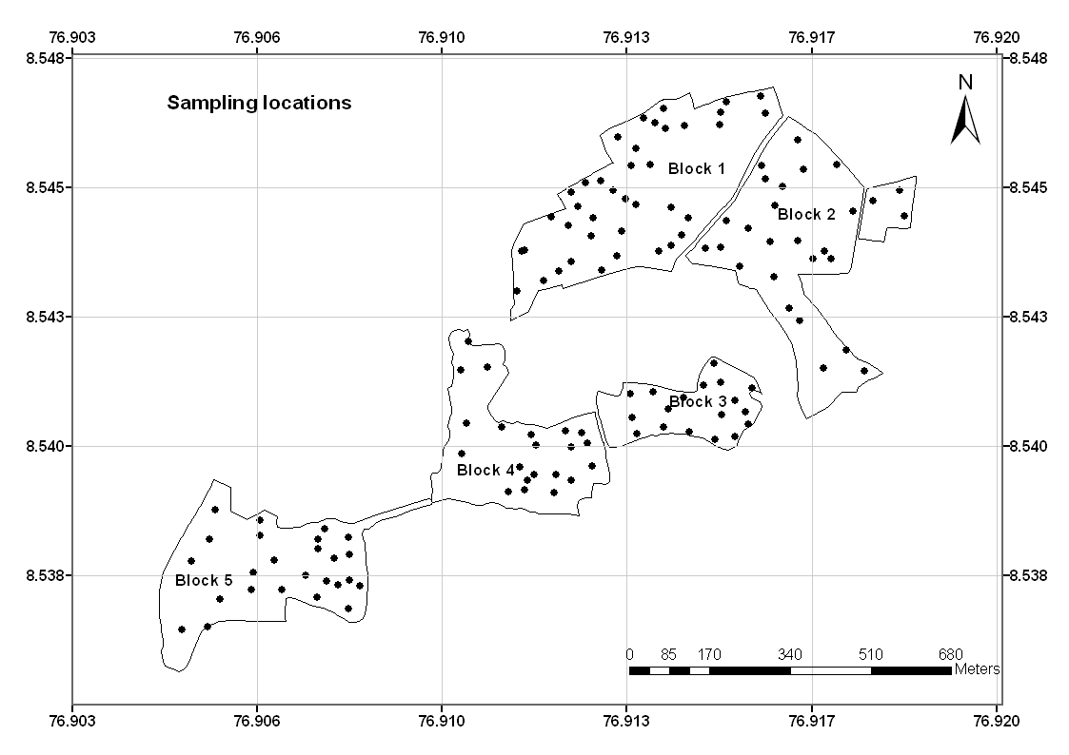
Fig. 1. Locations of sampling points in the experimental farm of CTCRI, India

0-15 cm |  | 15-30 cm
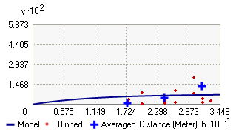 |  | 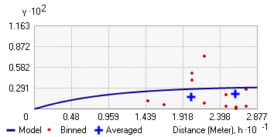
Bulk density
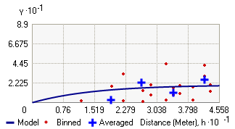  Water holding capacity |  | 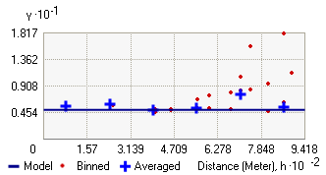
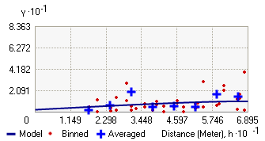  Porosity |  | 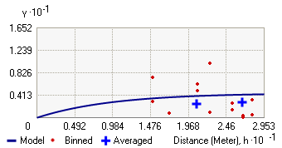
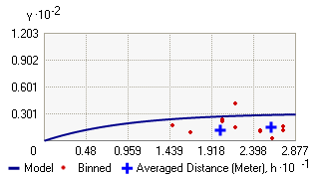  Sand | 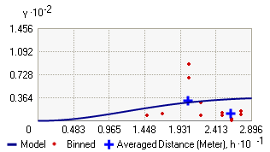
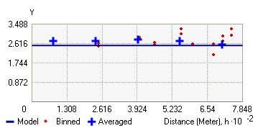  Silt | 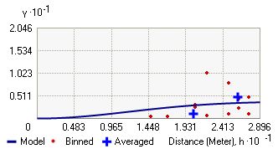
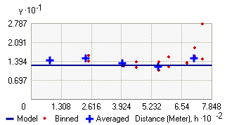  Clay | 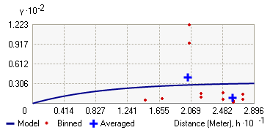
Fig. 2. Experimental and model semivariograms of soil physical properties

0-15 cm | 15-30 cm
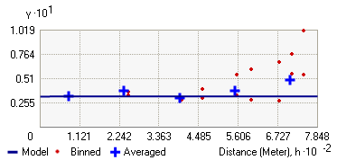 | 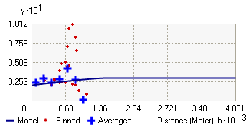
Organic carbon
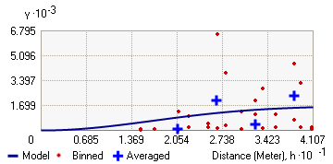 | 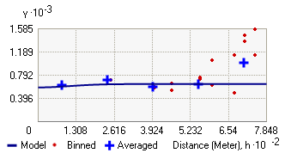
Available nitrogen
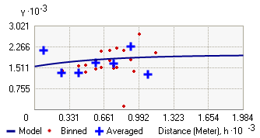 | 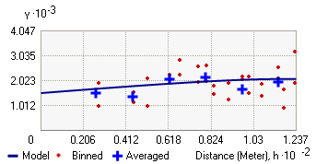
Available phosphorus
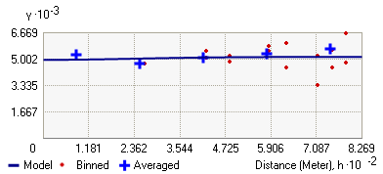 | 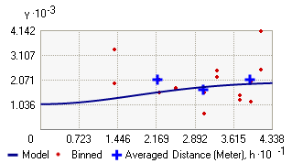
Exchangeable potassium
Fig. 3. Experimental and model semivariograms of soil chemical properties

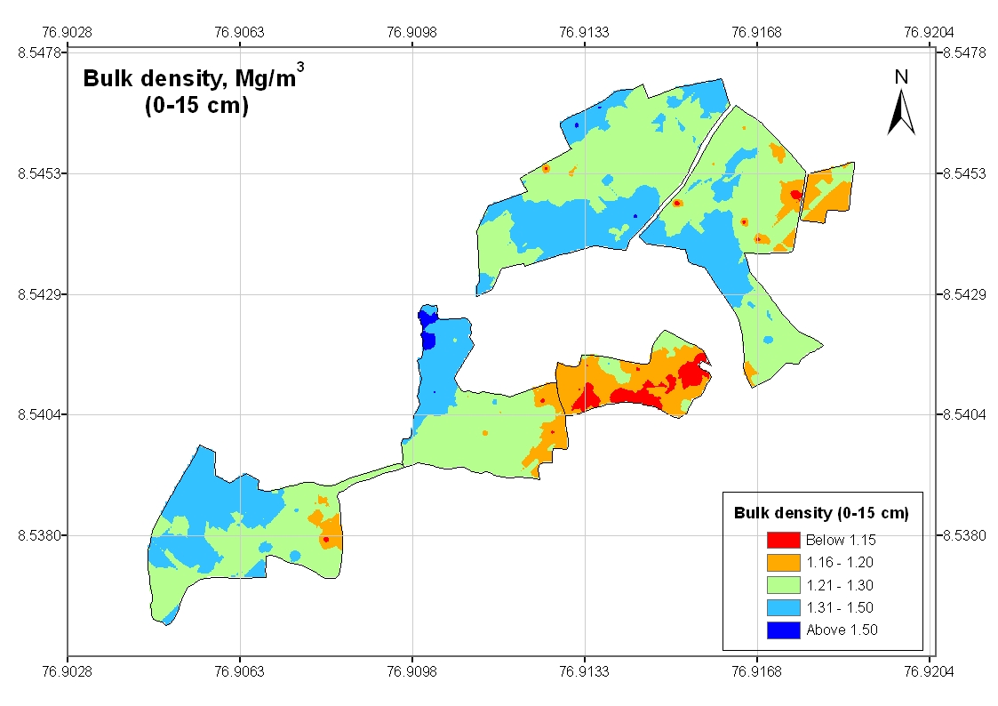 | 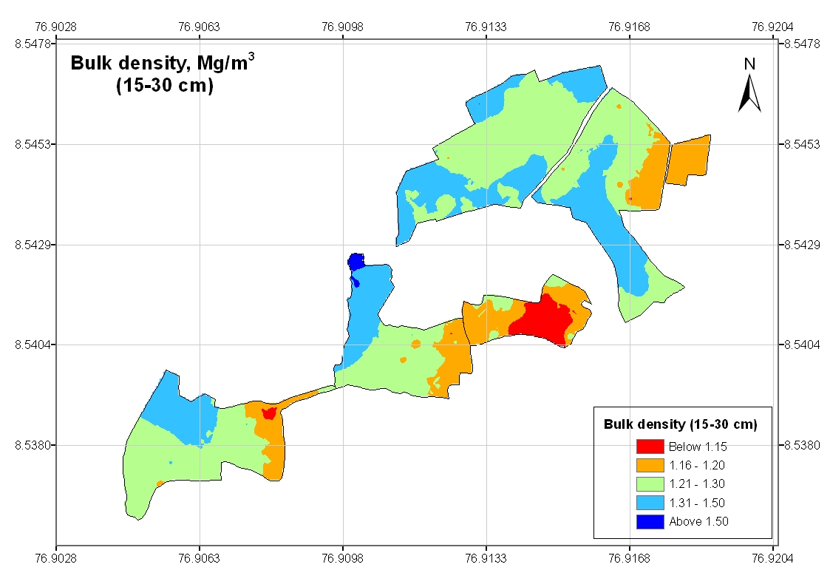
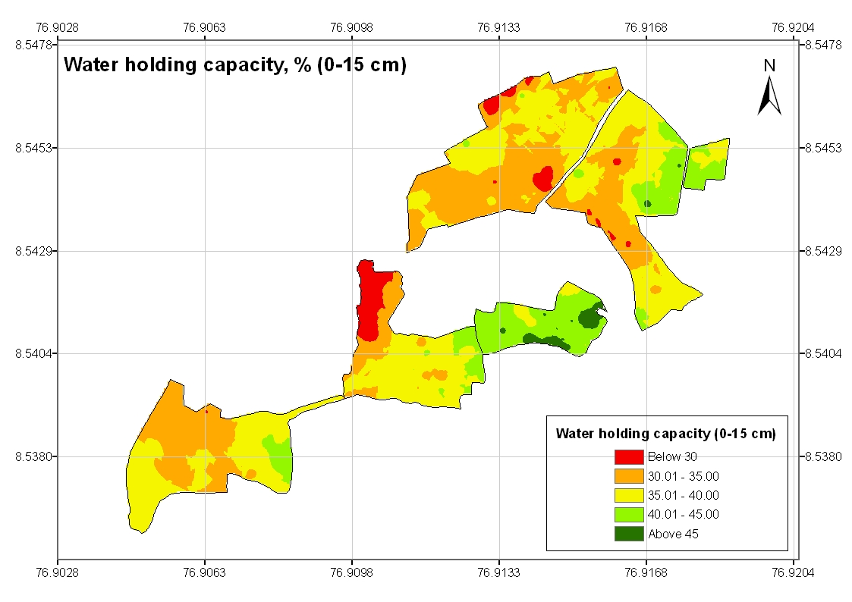 | 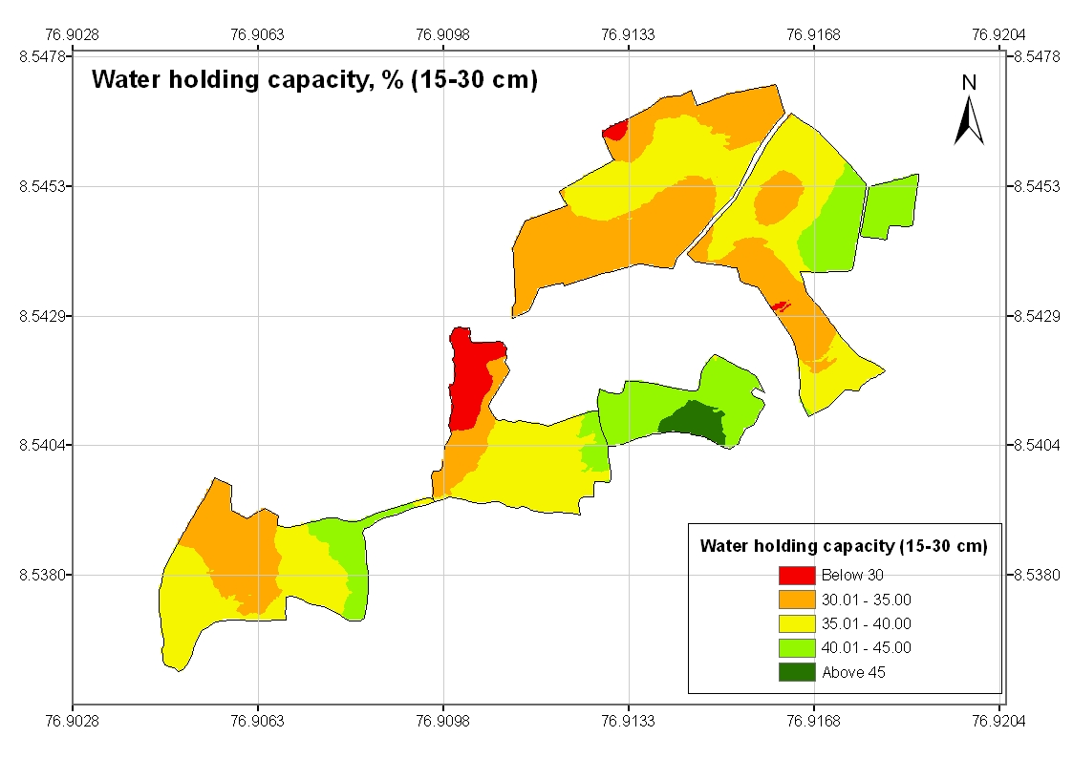
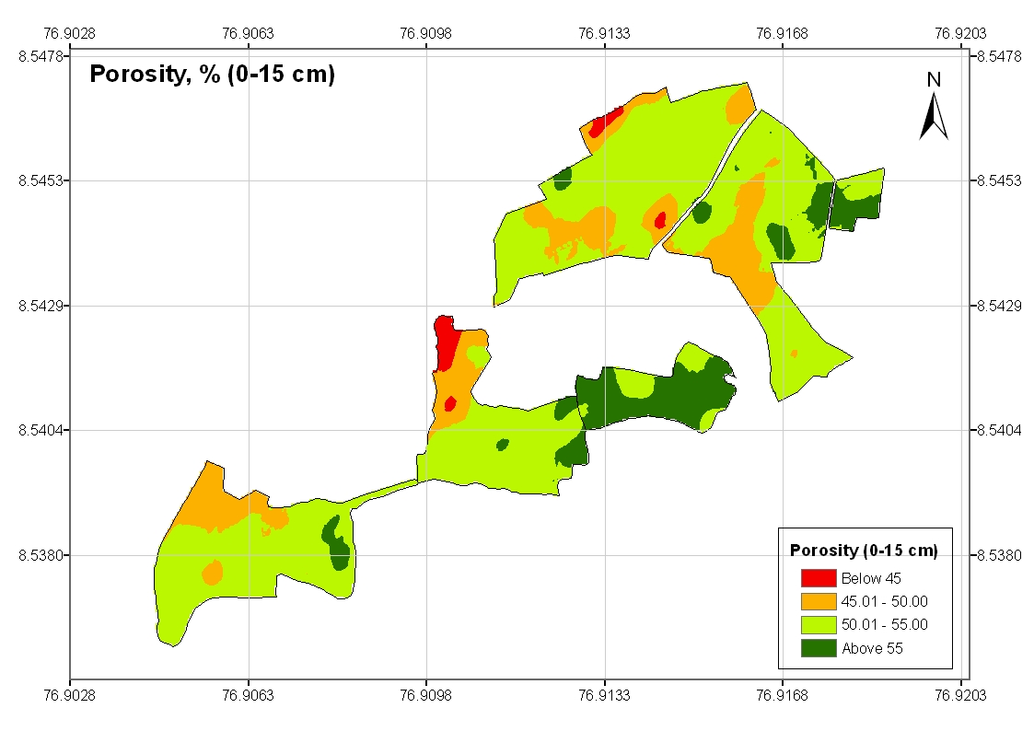 | 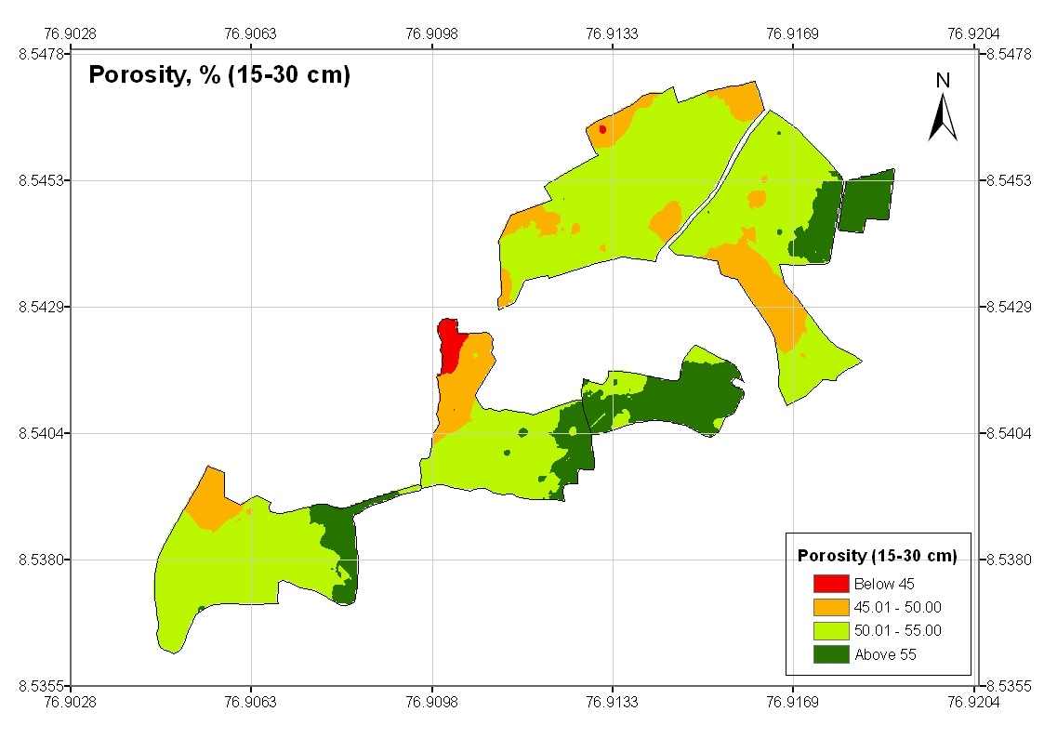
Fig. 4. Kriged maps of bulk density, water holding capacity and porosity

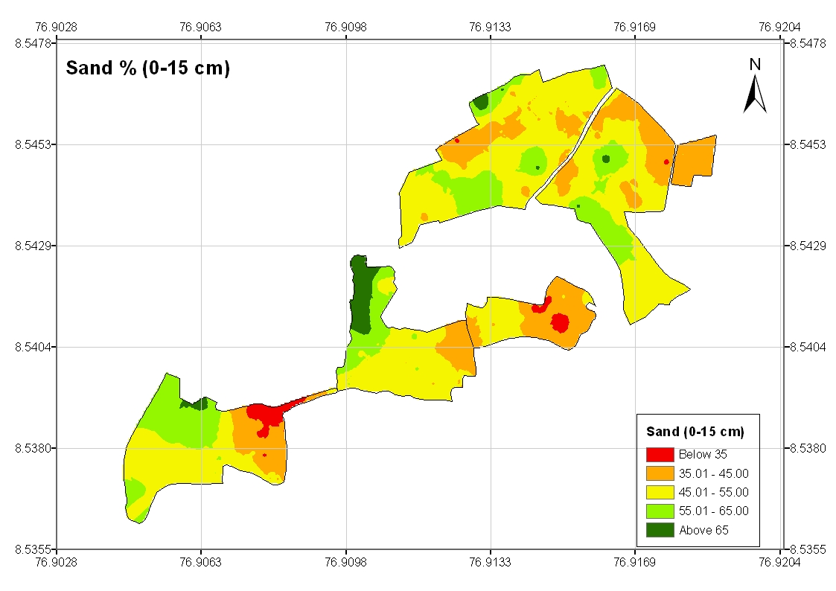 | 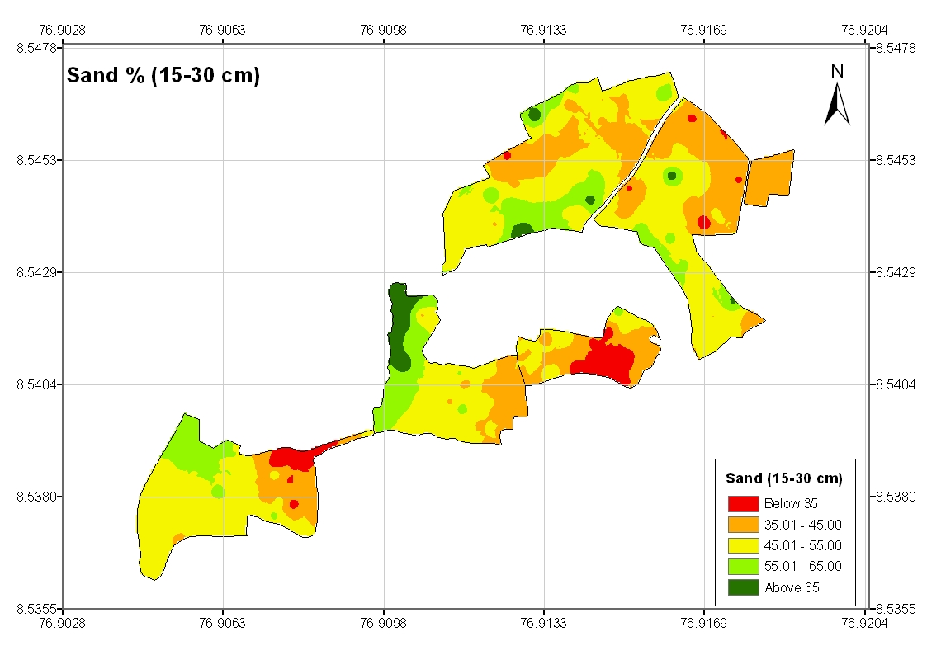
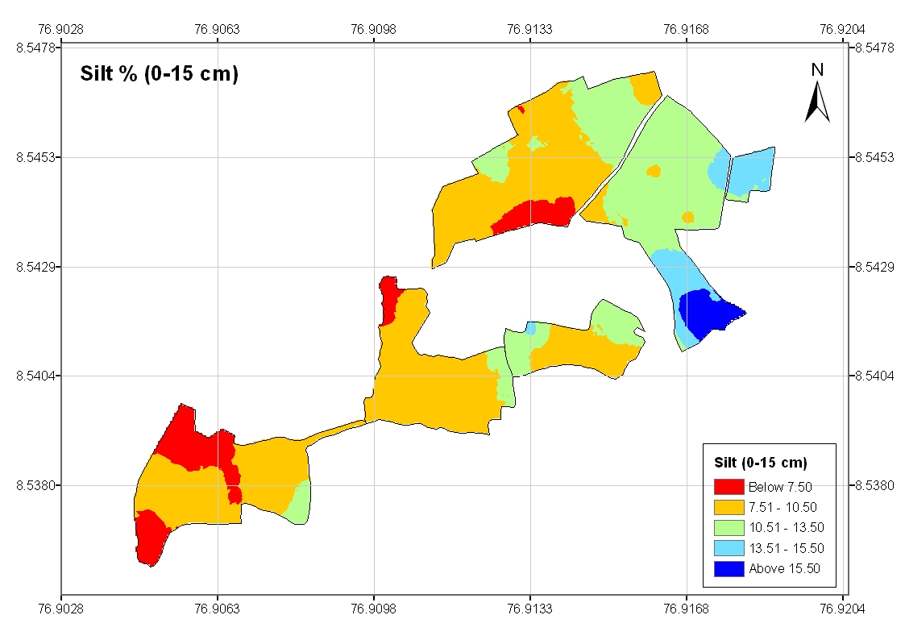 | 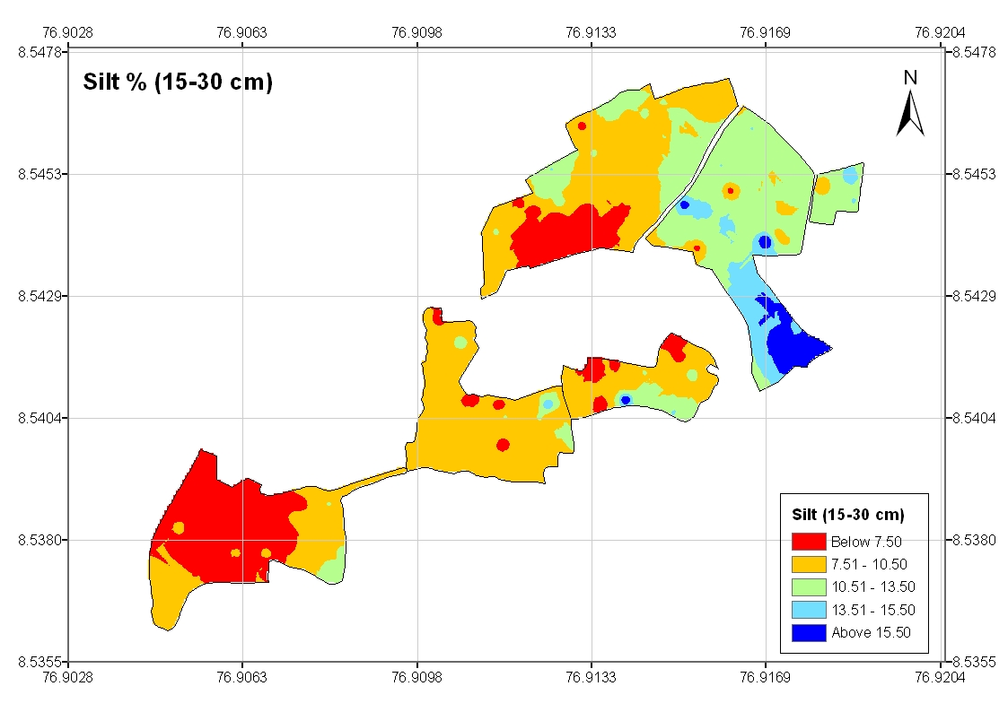
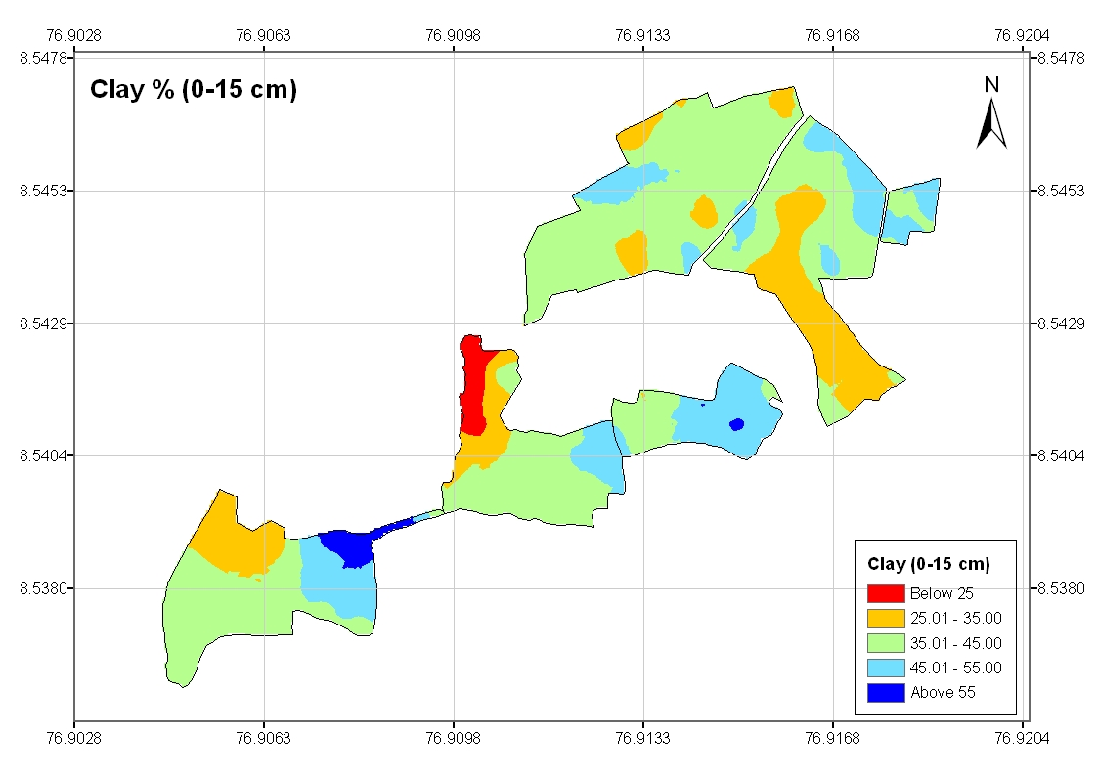 | 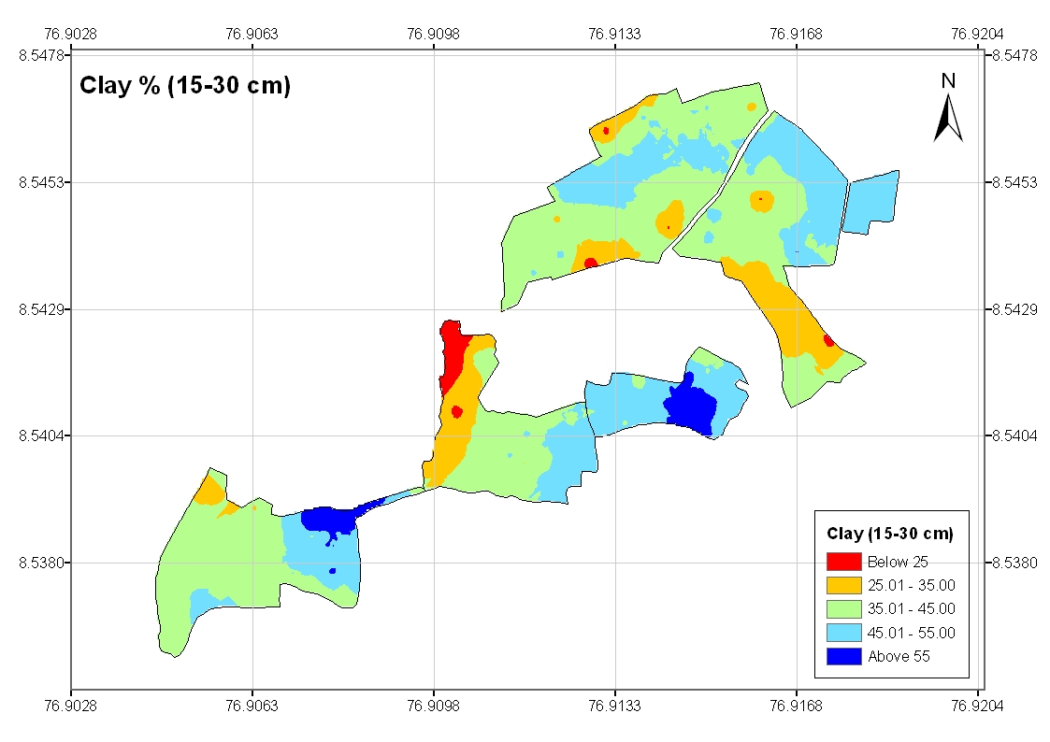
Fig. 5. Kriged maps of soil textural characteristics

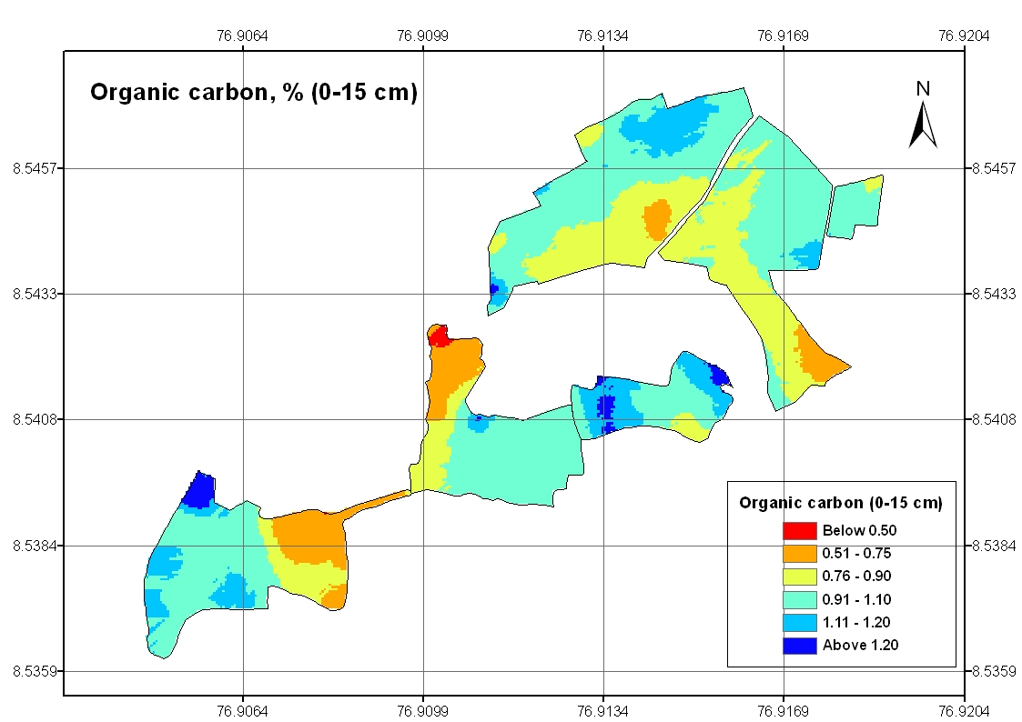 | 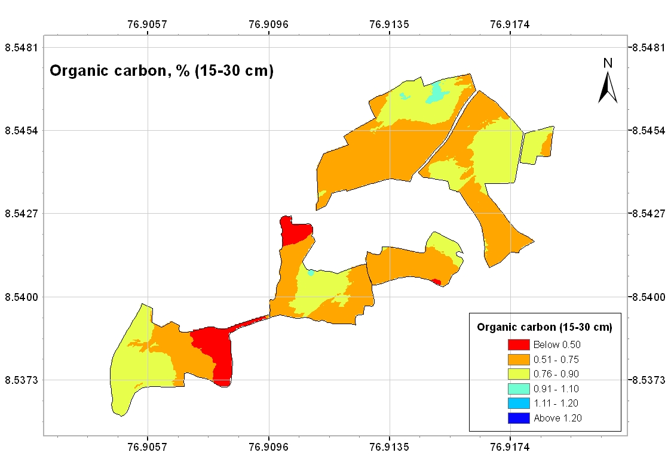
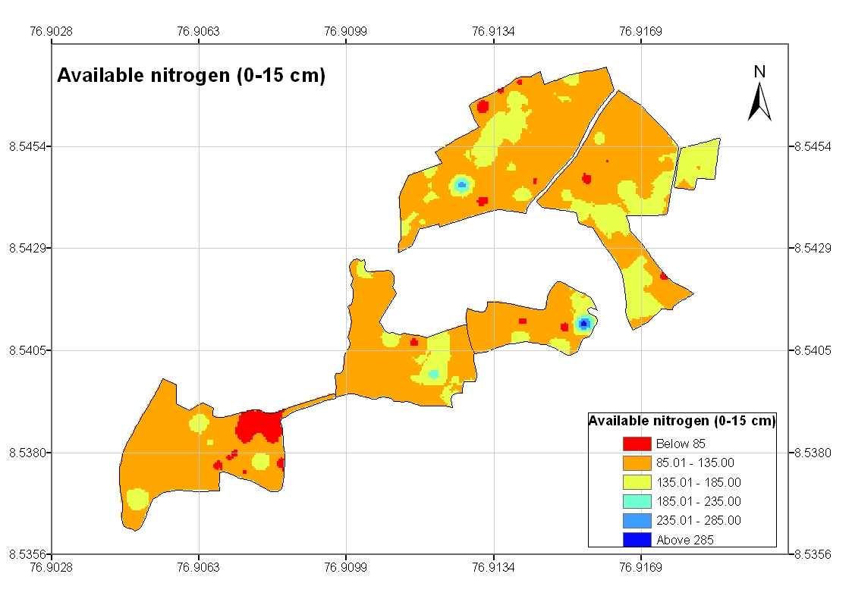 | 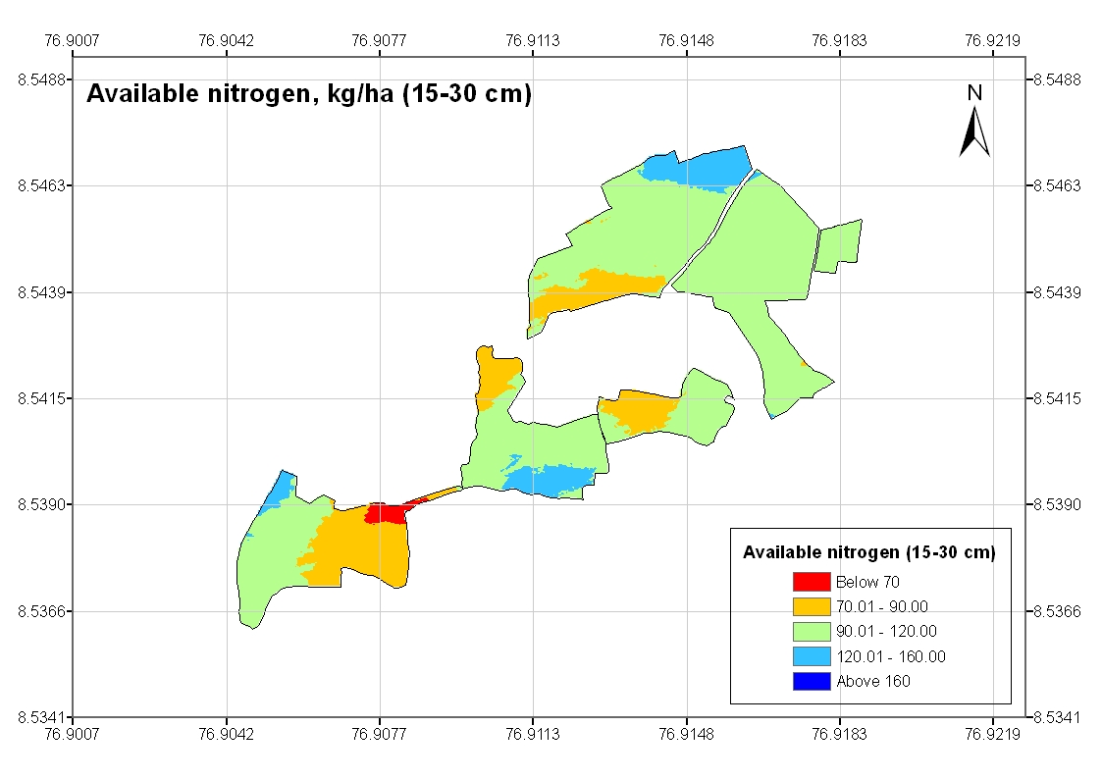
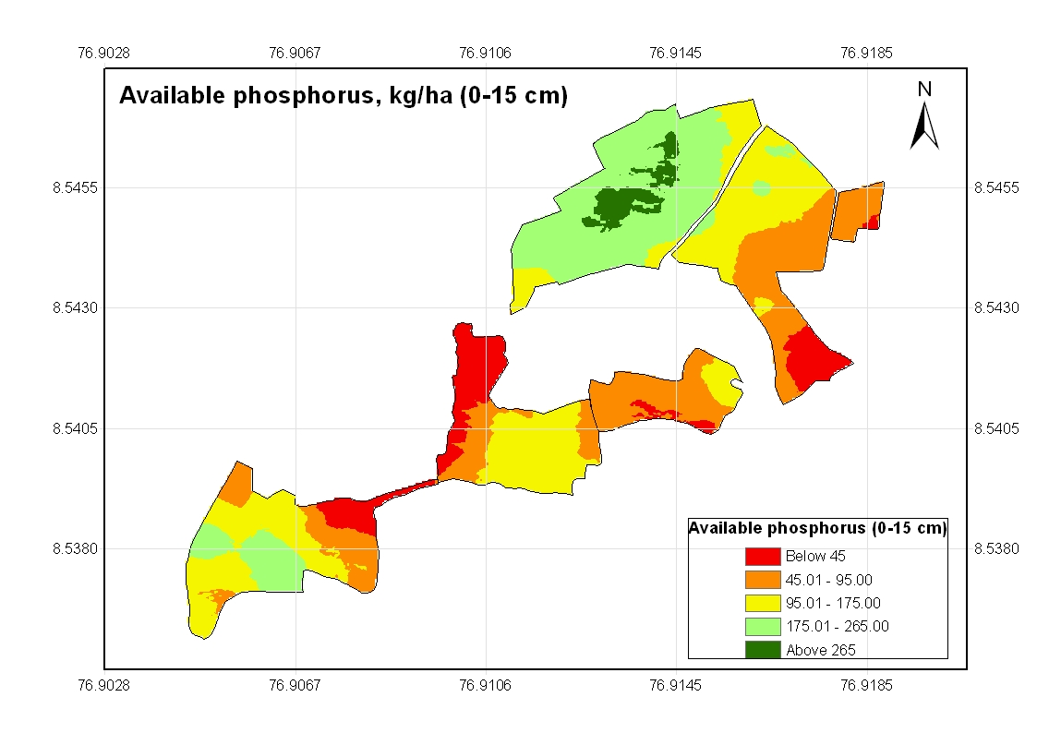 | 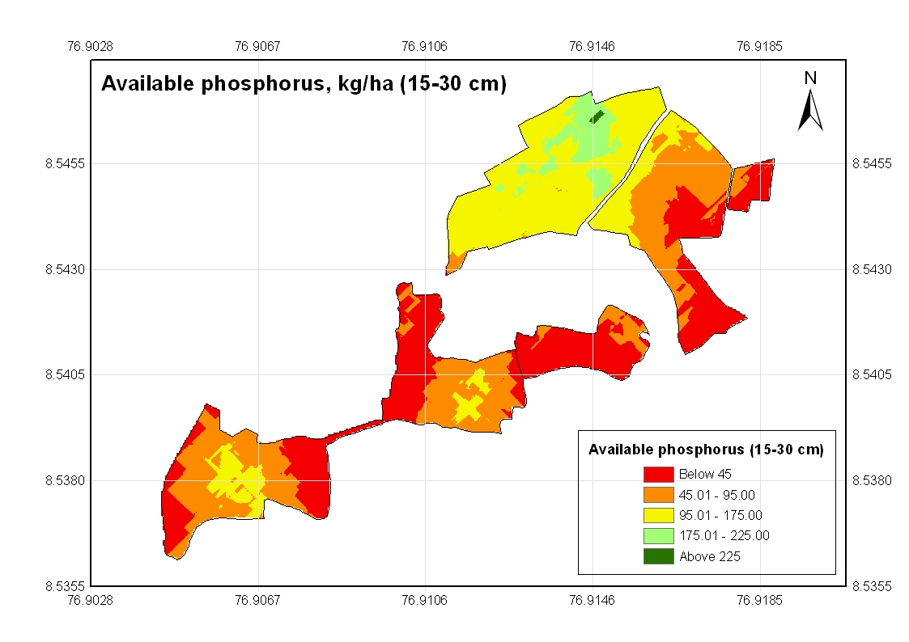
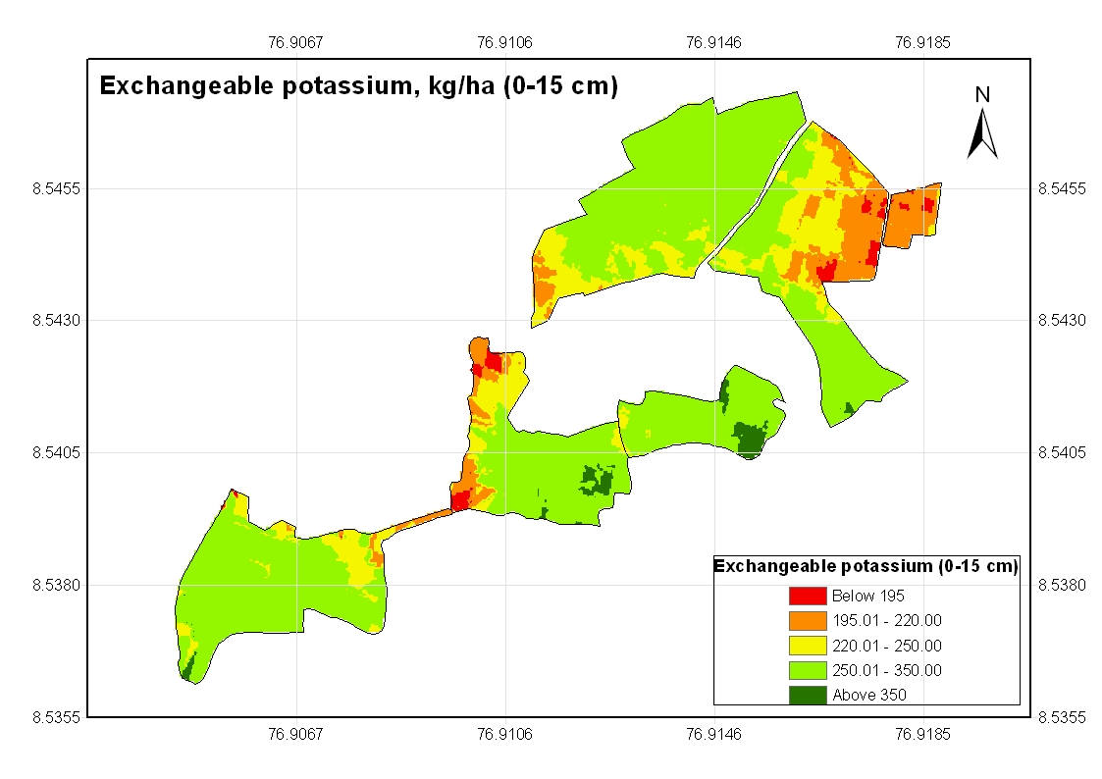 | 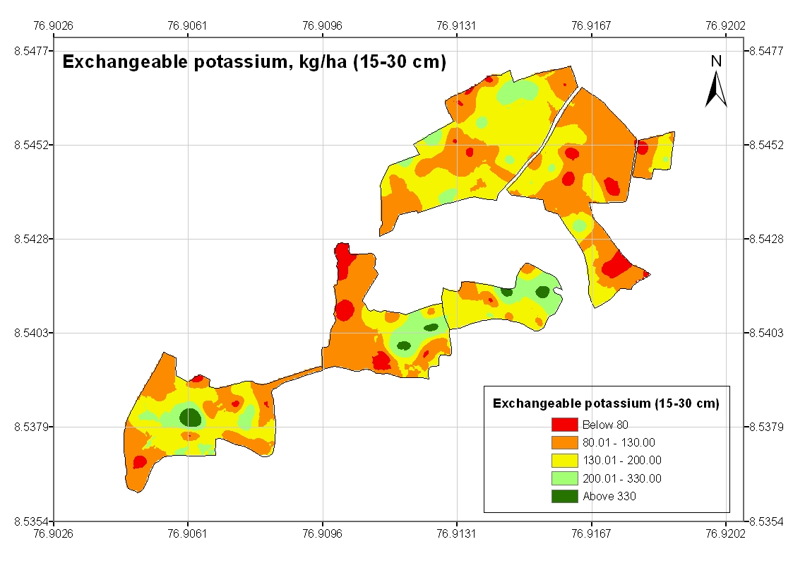
Fig. 6. Kriged maps of soil chemical properties

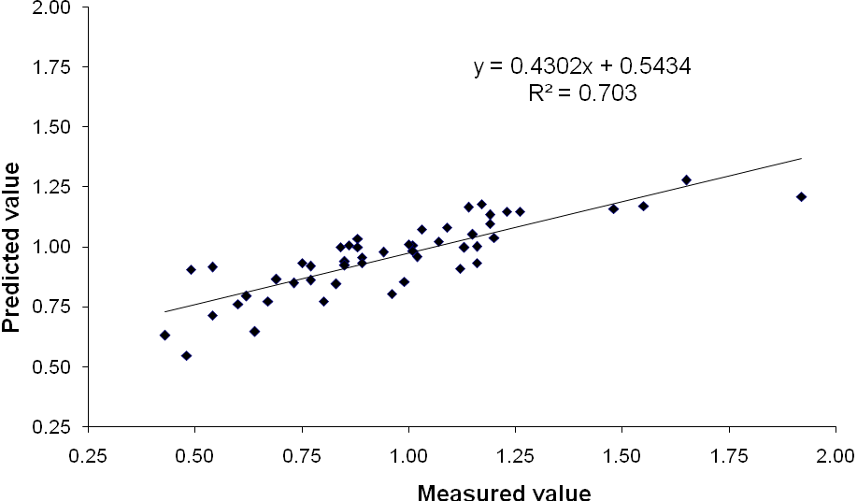
Fig. 7. Relationship between measured and predicted values of soil organic C (0-15 cm)

