- Planting material stock
- Publications
- Planting material request
- Publications
- Project status
- Planting material sales status

Project coordinator
Centres
Views
AICRPTC website
Views

Used by
General public

Updates by

Requests by

Sends

Planting materials

Updates by
- Staff data of PC unit
- Budget
- Publications
- News & Events
- Project format

- Planting material stock
- Germplasm data
- Staff data
- Budget
- Publications
- News & Events
- Project data
- University data
- Planting material sales
- Messages
- Reports
- Documents

Chat with
Chat with

- Other centres
- Project coordinator
- Centres
- General public

Receive from
Receives
- Messages
- Reports
- Documents
Receives

- Messages
- Reports
- Documents
Sends
- Other centres
- Project coordinator

Receive from

Sends to
- Messages
- Documents
Centres

- Other centres
- Project coordinator

Sends to
- Other centres
- Project coordinator

Fig 1. www.aicrptc.in entity-relationship diagram

Central database
Budget
Centre_basic
Chat_login
Chatpage
Chatroom
DR university
Email address
Germplasm
Messages
News_events
Pcchatlogin
Pcchatroom
Pcspeech
Pctour
Plt_material
Plt_request
Pltmaterial_sales
Proj_activity
Proj_factors
Proj_observations_data
Proj_report
Proj_weather
Projects
Publications
Reports
Staff
Tsp
User
Visitors

Project coordinator

Centres

Public

Fig 2. Schematic representation of data flow between public, centres and project coordinator
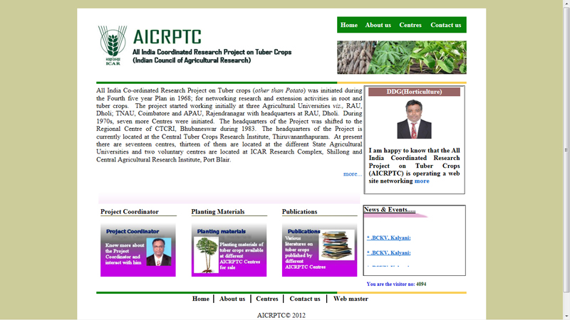
Figure 3.Home page of www.aicrptc.in

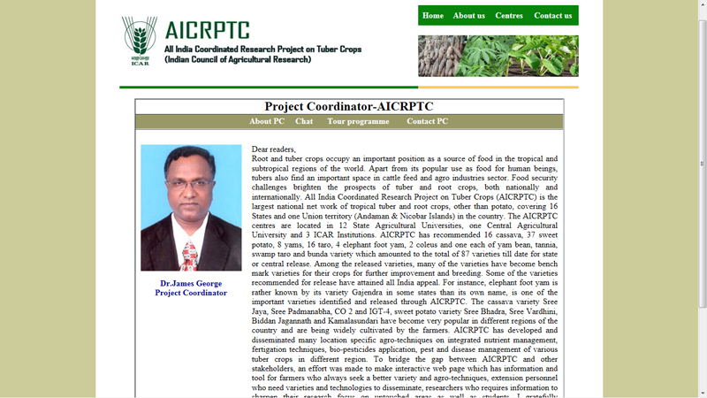
Figure 4. Project Coordinator 's section

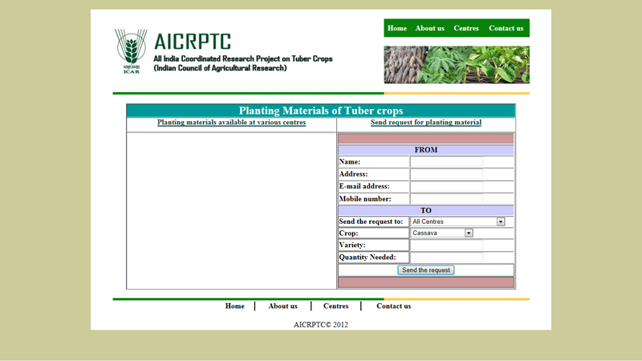Figure 5. Planting materials section

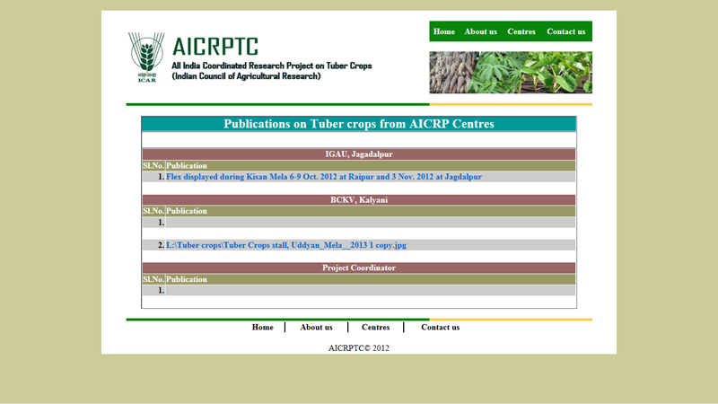
Figure 6. Publication section
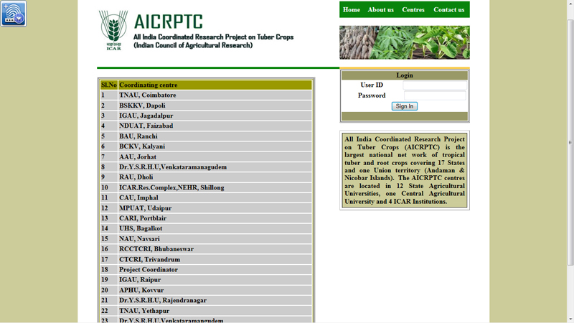
Figure 7. Coordinating centres of AICRPTC

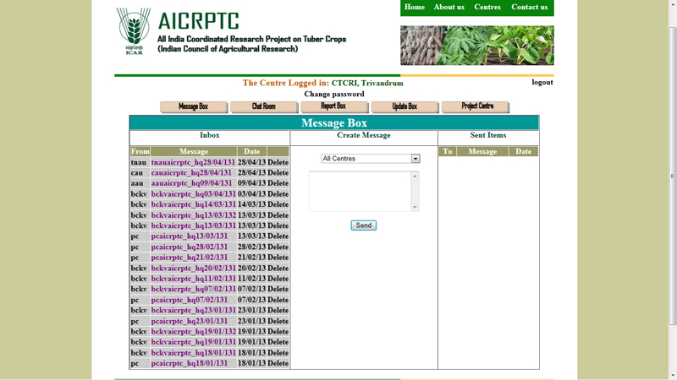
Figure 8. First page of the section on a centre of AICRPTC

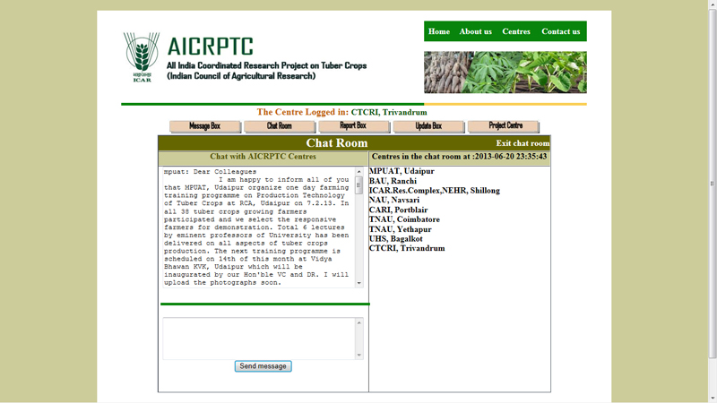
Figure 9. Chat room of the centre

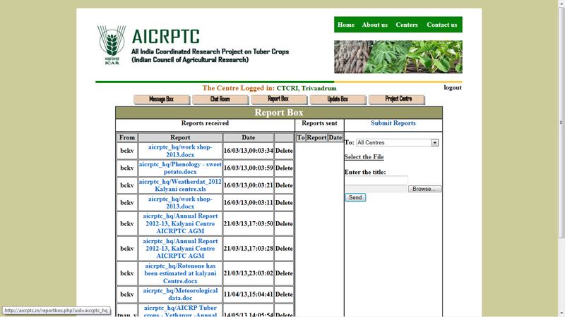
Figure 10. Report box of the centre

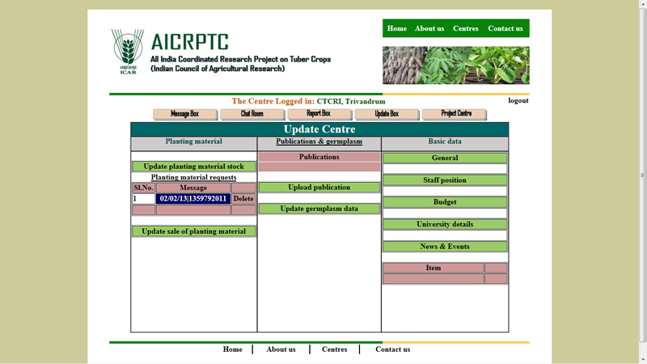
Figure 11. Update centre of the Coordinating centre

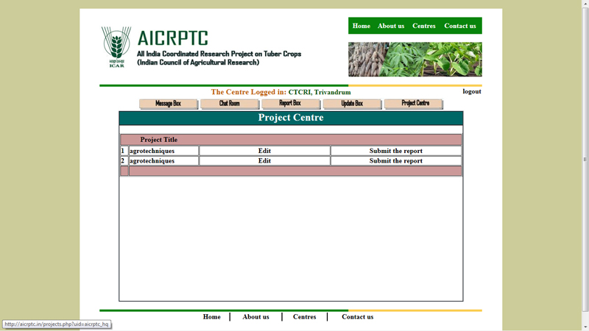
Figure 12. Project centre of the section

Table 1: List of tables at the back end of the website www.aicrptc.in
Sl.No. | Table name | Number of fields | Primary key
1. | budget | 13 | centre
2. | budget_instlmt | 10 | cy_id
3. | budget_total | 21 | cy_id
4. | centre_basic | 13 | name
5. | chatlogin | 3 | lid
6. | chatpc | 3 | uid
7. | chatroom | 5 | chatid
8. | dr_university | 7 | centre
9, | emailaddress | 2 | uid
10. | germplasm | 6 | germid
11. | messages | 6 | msgcode
12. | n_neh | 21 | cy_id
13. | neh | 21 | cy_id
14. | newsevents | 4 | newsid
15. | pcchatlogin | 2 | uid
16. | pcchatroom | 3 | chatid
17. | pcspeech | 2 | uid
18. | pctour | 3 | tourID
19. | plt_material | 6 | cid
20. | plt_request | 11 | rqstid
21. | pltmaterial_sales | 8 | pmID
22. | proj_activity | 7 | proj_activityID
23. | proj_factors | 3 | factor_code
24. | proj_observations | 6 | ob_id
25. | proj_observations_data | 5 | ob_code
26. | proj_report | 7 | report_id
27. | proj_weather | 10 | proj_id
28. | projects | 19 | proj_id
29. | publications | 4 | pubID
30. | rep | 3 | proj_id
31. | reports | 6 | reportID
32. | staff | 7 | staffID
33. | tsp | 21 | cy_id
34. | users | 3 | uid
35. | visitors | 2 | vno

